Savlink Detachable 8K Fiber Optical HDMI MPO Cable
Extender Kit

8K@60Hz ▏300M ▏48Gbps

Model: (SHMP-9860)

Specification

ECN Change History Form
Edition | Release Date | Change Details | Prepare | Verify | Ratify
1.0 | 2026.7.8 | First Edition Release | Huang Xiting
Product View
SAVLINK 8K Fiber Optical HDMI 2.1 Extender Kit redefines professional AV connectivity with its pure fiber optic architecture. This cutting-edge solution utilizes high-performance VCSEL lasers and photoelectric modules to deliver full HDMI 2.1 performance, supporting 48Gbps bandwidth, 8K@60Hz resolution, HDR, VRR, and eARC over extended distances without signal degradation.
Its ultra-slim, flexible design and MPO-based modularity revolutionize installations, allowing HDMI connectors to be replaced independently without rewiring. The pure fiber design ensures complete immunity to EMI, while the low-power architecture and auto standby mode minimize energy consumption. Requiring only a 5V USB power supply, it is perfectly suited for in-wall deployments. Ideal for 8K home theaters, esports, broadcast, and medical imaging, this kit offers unparalleled reliability and future-proof scalability for demanding ProAV environments.
The special stainless steel armored structure of the cable ensures bend flexibility, tensile strength, compression resistance, and tangle-free for durability and reliable performance。

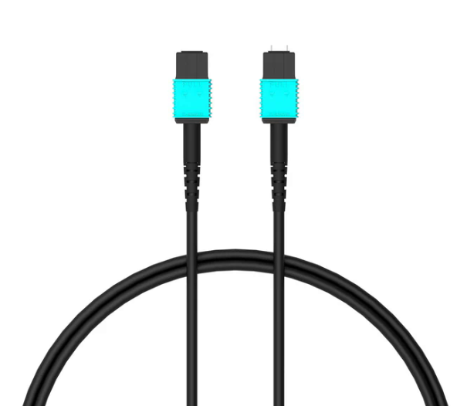

- Product Features
- Fully compliant with HDMI 2.1; backward compatible with HDMI 2.0/1.4.
- Up to 48 Gbps bandwidth; supports 8K@60Hz & 4K@120Hz stably.
- ·Supports HDR, HDR10+, and Dolby Vision for vivid, true-to-life visuals.
- ·Transmits uncompressed Dolby Atmos, DTS:X, TRUE-HD; up to 32 channels lossless.
- 7-core OM3 multimode fiber enables stable EDID/HDCP bidirectional communication.
- Hot-swappable MPO connectors simplify installation and future maintenance.
- Supports VRR, ALLM, QFT, QMS—low latency, no tearing or lag.
- Compatible with ARC/eARC; supports HDCP 1.4/2.2/2.3 across AV devices.
- EDID auto-negotiation; plug-and-play, driver-free operation.
- Pure fiber design; immune to EMI/RFI; zero attenuation over long distance.
- Ultra-slim, lightweight LSZH jacket; ideal for tight-space cabling.
- Low-power, high-stability design; supports OEM/ODM customization.
- For reliable CEC, connect both ends to a stable 5V USB power source
- Rugged Armored Protection

- Performance Parameters
2.1 The performance specifications of the Detachable 8K Fiber Optical HDMI MPO Cable Extender Kit are shown in the table below:
Parameter | Specification
Interface type | 2 x HDMI Male Golden Plated
Maximum bandwidth | 48 Gbps
Maximum Resolution | 7680 × 4320 @ 60Hz (8K UHD) 1080p/1440p @ 240Hz, 4K @ 120Hz, 5K @ 60Hz
Color Format | RGB，YCbCr 4:4:4 / 4:2:2 / 4:2:0
Color Depth | 8-bit, 10-bit, 12-bit
HDR support | Dynamic HDR, HDR10, HDR10+
HDCP​ | HDCP 2.3
Audio Support | DSC 1.2a eARC ,Dolby,Atoms 7.1
Game Features | VRR, ALLM, QFT, QMS
Power input | USB 5V
Working Voltage Range | 4.9V ~ 5.3V
Power Consumption | 280mW ~ 600mW
Cable | 7C *50/125 μm OM3 multi mode optical fiber
O/E Converter | VCSEL (850 nm)
Max Length | 300 m (1000 ft)
Cable OD | 3.0 mm
External Material | LSZH: Low-smoke, halogen-free
Min Bending radius | 30nn
Insertion/ Removal lifespan | ≥ 10,000 times
Instation | Simply connect the MPO male connector to the front, the MPO female connector to the rear of the keystone for a quick and hassle-free setup
Working Temperature | 0°C to +70°C
Storage Temperature | -20°C to +70°C
Working Humidity | Relative humidity ranges from 5% to 85% (non-condensing type).
Storage Humidity | Relative humidity ranges from 5% to 85% (non-condensing type).
Product Certification | CE / FCC / RoHS / REACH
Cable Length | An MPO cable is optional; the length can be customized.
Shell | Zinc shell or custom design
Package | 1PCS/ Anti-Static Foil Bag +Yellow Box

2.2 Supported Video Format Parameters:
Resolution ratio | Refresh rate | Color Format | Color Depth
4K | 60Hz / 120Hz | 4:2:0 / 4:2:2 / 4:4:4 | 8/10/12bit
5K | 60Hz / 120Hz | 4:2:0 / 4:2:2 / 4:4:4 | 8/10bit
8K | 60Hz | 4:2:0 | 8/10/12bit
10K | 24Hz / 30Hz | 4:2:0 / 4:2:2 / 4:4:4 | 8/10bit
2.3. Signal Flow Description and Working Principle Block Diagram
Stage | Description
① HDMI Source → TX​ | The source outputs standard HDMI 2.1 electrical signals (TMDS/FRL), supporting 8K@60 4:4:4, VRR, HDR, etc.
② TX Internal Processing​ | HDMI 2.1 receiver → Ser Des/FRL encoding → VCSEL driver array. Converts 4 high-speed differential pairs plus auxiliary signals into multiple optical signals.
③ TX → MPO Fiber​ | Parallel optical transmission via MPO multi-core OM3 multi mode fiber (850 nm). Pure optical path with zero EMI.
④ MPO → RX​ | Photo diode array receives optical signals → TIA (Trans impedance Amplifier) / Deserializer restores electrical signals.
⑤ RX → HDMI Sink​ | HDMI 2.1 transmitter outputs standard HDMI electrical signals to the display device.
⑥ Control Channel​ | Bidirectional low-speed control signals (DDC/EDID/HPD/eARC, etc.) transmitted via the fiber (indicated by dotted lines).
⑦ Power Supply​ | Both TX and RX modules require 5V power (partially bus-powered via HDMI port where applicable).

Ⅲ.Module and Cable Structure Drawings
3.1. Optoelectronic Module Architecture
TX (Source Signal Source):
➢ 5-channel 850 nm VCSEL laser + 2-channel GaAs photo-diode array
RX (Display End):
➢ 2-channel 850 nm VCSEL laser + 5-channel GaAs photo-diode array
3.2 Description of the MPO Cable Structure
Description: This product is compatible with third-party MPO Type-A (12-core OM3) fiber optic connection solutions.
Project | Explain
Optical Fiber Structure | 7 Core or 12 Core OM3 Multi-Mode
Connection Method | MPO Type-A
Wire Color | Blue
Material of the outer sheath | LSZH: Low-smoke, Halogen-free

3.3 Cable Structure Drawings
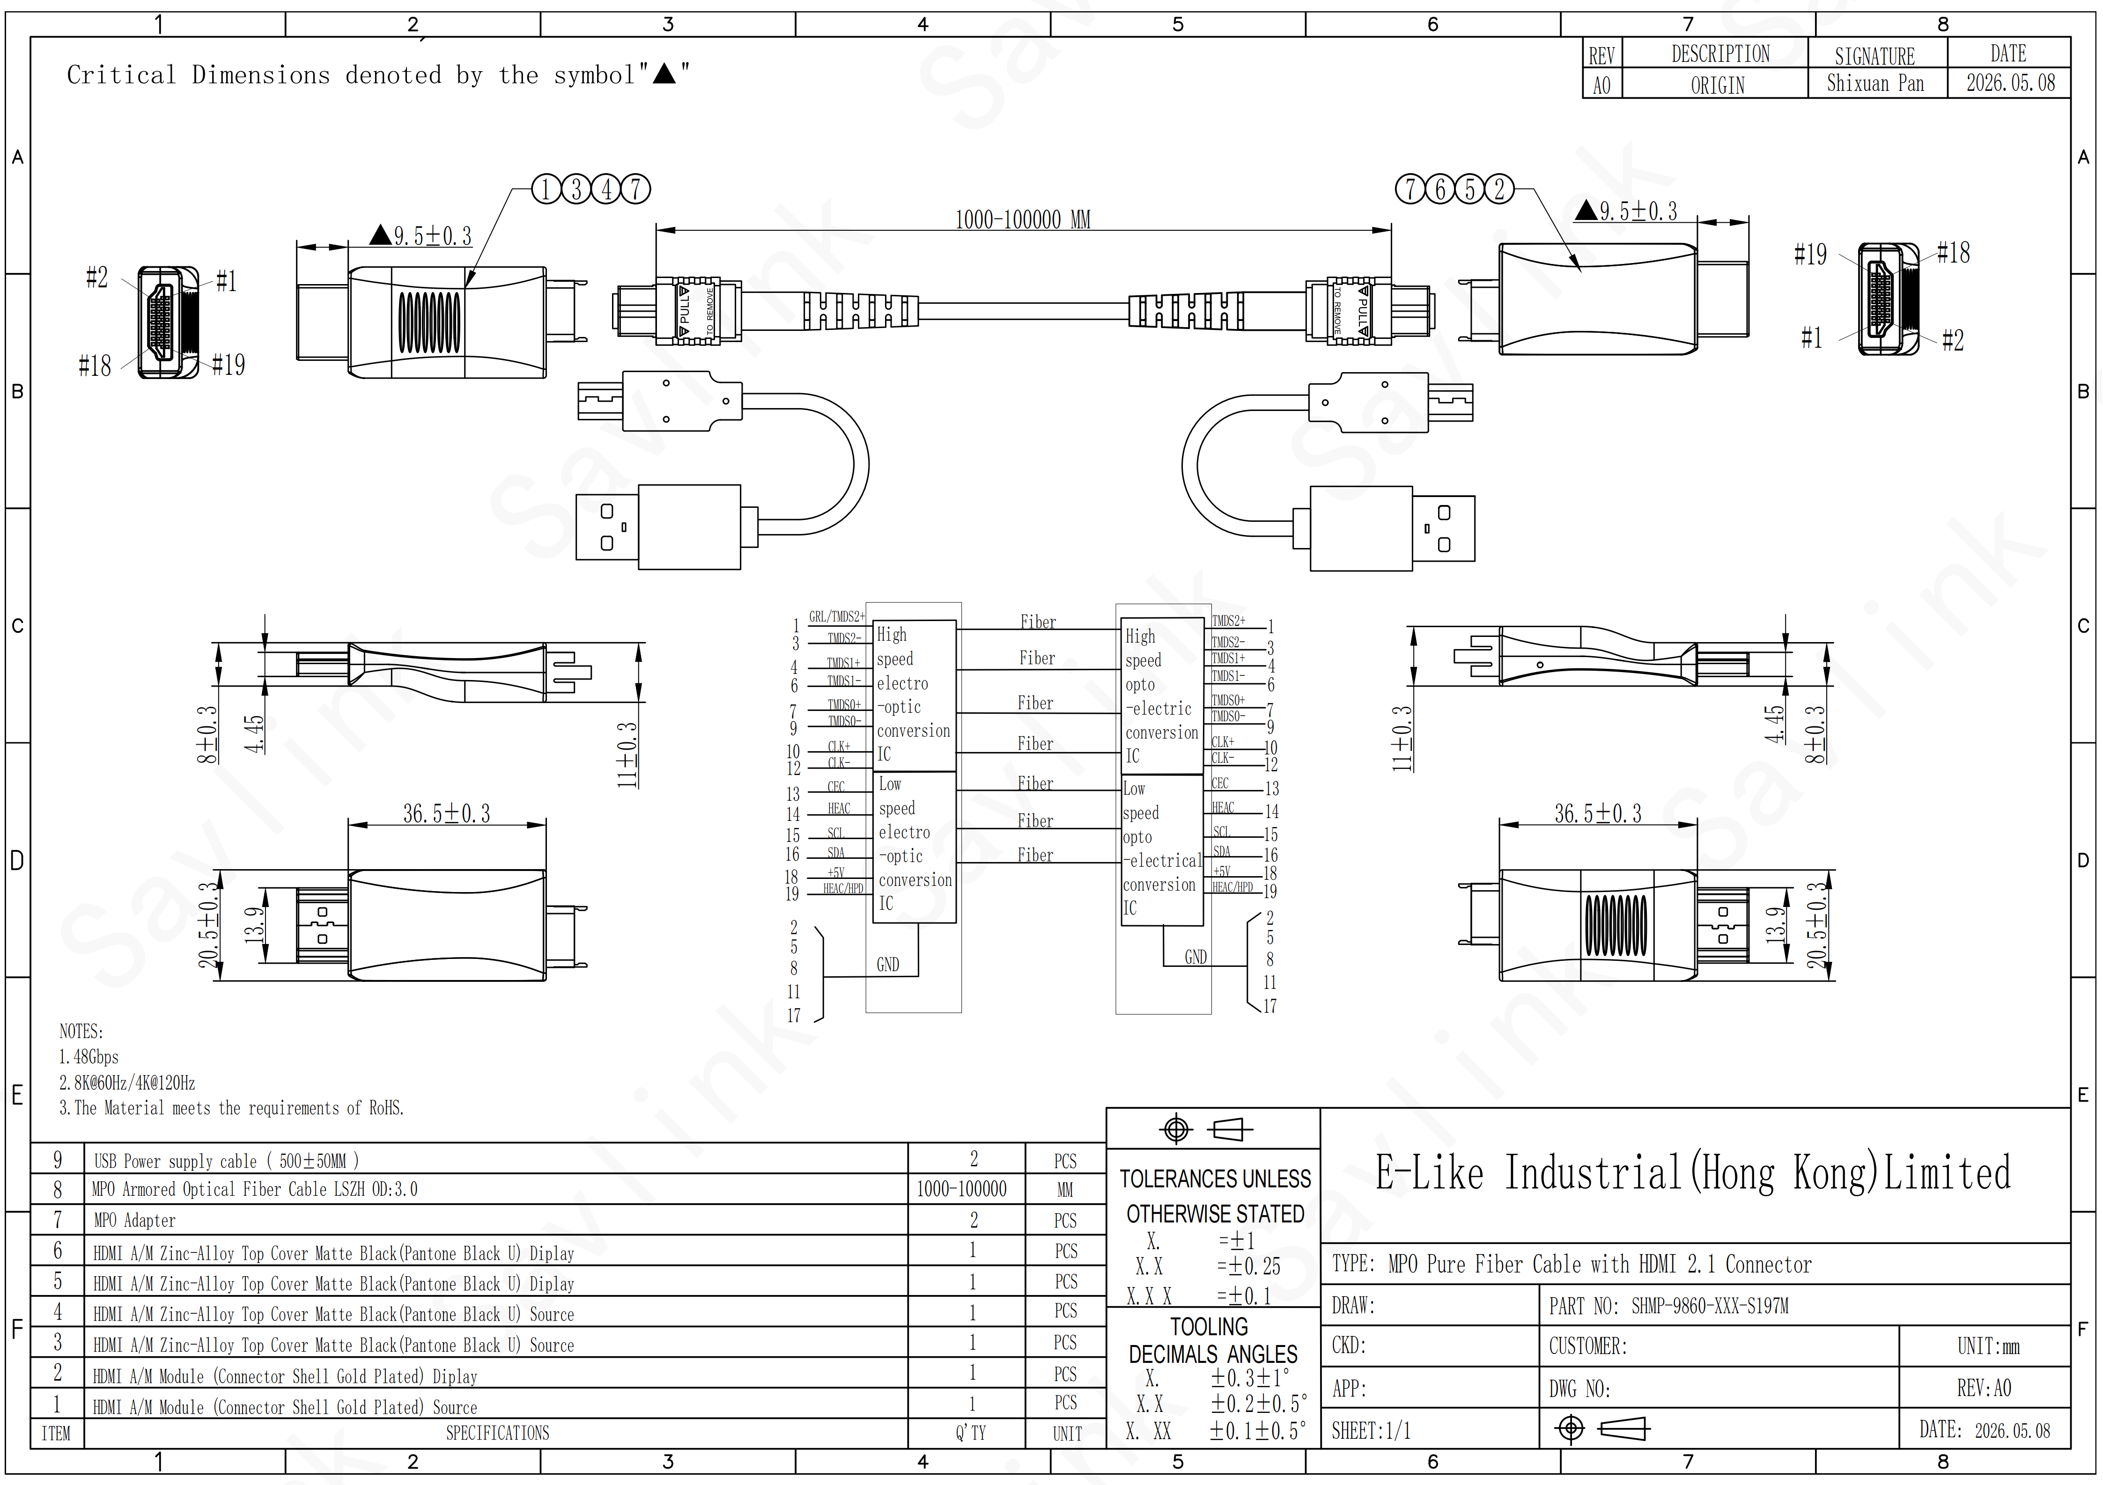
Ⅳ. Working Principle and Power Supply Specifications
4.1 Working Principle
- TX (Transmitter): Connected to the signal source side, it contains a VCSEL array/driver chip that converts HDMI 2.1's high-speed differential pairs (TMDS/FRL) and auxiliary signals (EDID, HDCP, HPD, eARC, etc.) into multiple optical signals.
- MPO fiber backbone: Multi core multi mode fiber (commonly OM3, 850 nm), dedicated to pure optical transmission without a copper core.
- RX (Receiving End): Installed on the display side, featuring a photo-diode and a TIA/industrializing chip that converts optical signals into standard HDMI electrical signals.

4.2Key design features of the "Detachable / MPO" model

The HDMI-TX and HDMI-RX modules can be separated from the fiber optic backbone via an MPO connector, rather than being integrated into a single rigid cable.
- During installation, first run the fine-diameter MPO fiber through conduits and pre-embed it in walls, regardless of Source/Display orientation (TX/RX modules will be installed later), to simplify cabling.
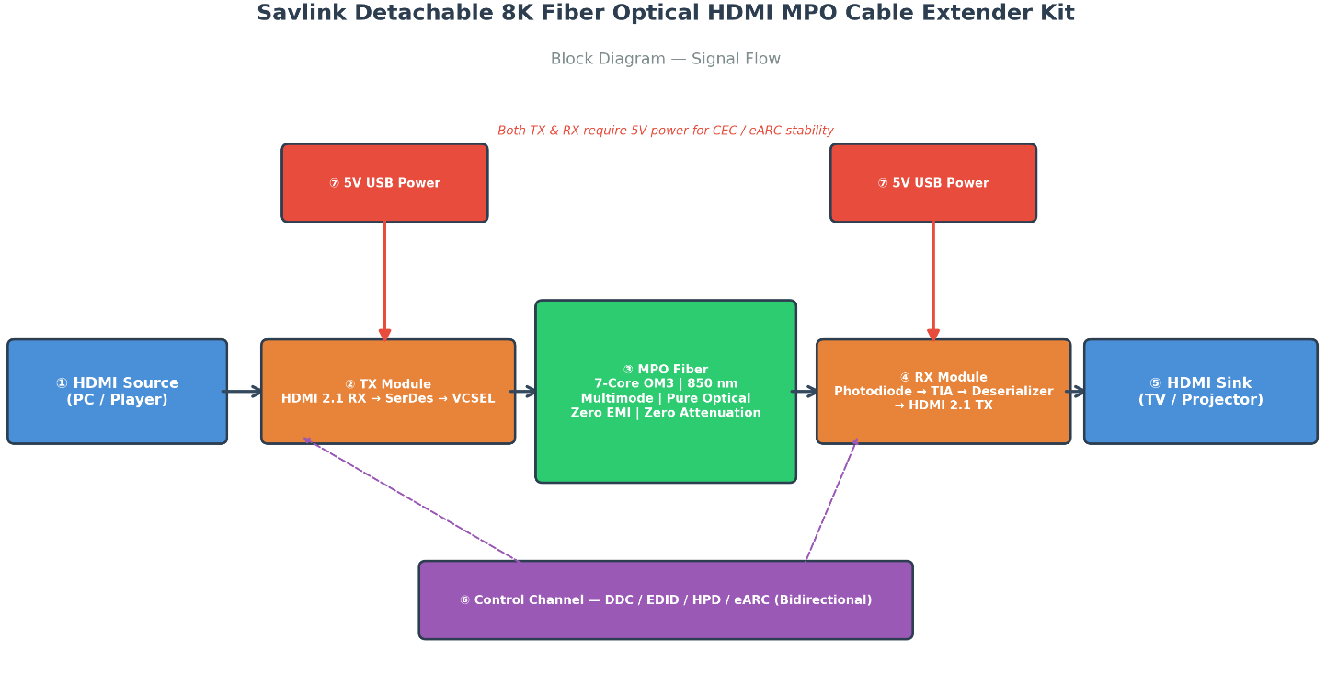

4.3Power Supply Specifications
This product employs a USB 5V power supply solution, with the following specifications:
Standard Usage Requirements:
- The RX (display unit) must be connected to a USB power cable to function properly.
The TX (signal source) must also be connected to a USB power adapter when certain devices lack sufficient power.
Usage recommendation: For long-distance transmission or high-power display devices, connect both the TX and RX ends to a 5V USB power supply simultaneously to ensure stable and reliable system operation.
Ⅴ:Applications
- 8K Home Theater System
- E-sports Displays and Gaming Equipment
- Commercial Displays and Digital Signage
- Security Monitoring Center
- Radio and Television Broadcasting Studios
- Medical Imaging Display System
- Data Center Room Display
- Stage performances and events held at the venue
- Industrial Control and Visualization
Ⅵ:Q&A
Q1: Are there any direction requirements for product connections? What problems can occur with incorrect connections?
A1: The HDMI adapter has directional requirements – the Source signal port must be connected to the Display output port; reversed connections will prevent proper signal transmission. Always verify the port orientation before use.
Q2: What are the precautions to observe when bending or pulling wire materials?
A2: Do not forcibly pull, twist, or crush the cable; avoid excessive bending. During use and installation, maintain a bending radius of at least 30 mm to prevent internal fiber fracture and signal transmission abnormalities.
Q3: How to resolve abnormal power supply issues with the device?
A3: For normal operation, ensure stable USB 5V power supply. If issues such as device recognition failure, screen flickering, or no signal occur due to insufficient power, connect the device to a standard 5V external power source. For long-distance transmission scenarios, simultaneous power supply at both ends is recommended.
Q4: What are the specification requirements for interface insertion and removal?
A4: It is recommended to connect or disconnect interfaces when the device is powered off to prevent damage to interfaces or module failures caused by hot-plugging, thereby extending product lifespan.
Q5: What happens if the TX (transmitter) and RX (receiver) are connected in reverse?
A5: Do not connect in reverse. Fiber optic HDMI is designed for unidirectional transmission; the TX end must be connected to a signal source (e.g., computer or media player), and the RX end must be connected to a display device (e.g., TV or projector). Reversed connection will result in no signal output (black screen).
Q6: Is the MPO fiber backbone directional? What are the requirements for its polarity?
A6: Yes, the MPO trunk requires attention to polarity. This product uses Type A polarity. Although originally designed for a 7-pin configuration, it is compatible with standard 12-pin MPO male connectors, Type A polarity, and OM3/OM4-grade cables.
Q7: What precautions should be taken when inserting an MPO connector?
A7: Follow these steps:
Before inserting or removing, always cover or uncover the dust cap to avoid touching the fiber end. Insert it aligned with the designated position. Ensure you hear a "click" sound indicating the connection is secure.
Q8: How to enable the CEC (Consumer Electronics Control) function?
A8: Activation of the CEC function requires continuous power supply. Both the TX and RX terminals must remain powered. For devices that cease receiving external power after shutdown, connect the included USB power cable to a continuously powered USB-A port (e.g., a charging port on a wall outlet) to ensure proper operation of features such as CEC standby wake-up.
Q9: Do both ends require external power supply?
A9: The display end (RX) typically requires a 5V power supply (USB-A/Micro-USB). The signal source end (TX) may use the HDMI port for power in some scenarios, but for optimal CEC/eARC stability, it is recommended to power both ends.
Q10: Can third-party MPO fiber cables be used interchangeably?
A10: Yes. You may use MPO cables from other brands as alternatives, provided they meet the following specifications: 12-core design, MPO female connector, Type A polarity, and OM3 or OM4 rating (originally 7-core but compatible with 12-core standard cables).
Q11: Will connecting an AV receiver or switch in between affect the performance?
A11: There will be an impact. The overall performance of the link depends on its weakest link. If the intermediate AV receiver or switcher only supports HDMI 2.0, the final output will be limited to HDMI 2.0 specifications. It is recommended to first test by bypassing intermediate devices.
Q12: What should I pay attention to before installation?
A12: Before installation, do not remove the protective label or dust cover from the cable. Do not fold or excessively bend the cable during wiring to avoid damaging the internal optical fibers.
Q13: Are fiber optic cables prone to damage? How should they be maintained regularly?
A13: Optical fibers are more fragile than copper cables and require specific bending radii (typically ≥20 mm in static conditions). Daily maintenance should focus on protecting the joints: use a dedicated MPO cleaning brush or brush sleeve to clean the end surfaces; avoid manual contact. Before formal wall installation or conduit burial, 반드시 connect the source end and display end and perform a full-resolution pressure test.
Q14: How should I handle a dirty MPO joint?
A14: Do not blow or wipe with a dry paper towel. Use a professional MPO fiber cleaning pen for cleaning, as this is essential for maintaining signal quality.
Q15: If the HDMI connector is damaged, do I need to replace the entire cable?
A15: Not required. This product features a detachable design; the HDMI module (TX/RX heads) can be purchased and replaced separately, eliminating the need to re-install the fiber optic backbone.
Q16: Will rewiring be required when upgrading to the new video interface standard in the future?
A16: Not required. This is the core advantage of this product. If the interface standard upgrades in the future (e.g., to DP 2.0 or other protocols), you only need to replace the conversion modules at both ends; the pre-installed MPO fiber trunk within the wall can be reused.
Q17: Can I only purchase a separable HDMI connector (TX/RX)?
A17: The separable connector is available for purchase separately.
Ⅶ:Related Series
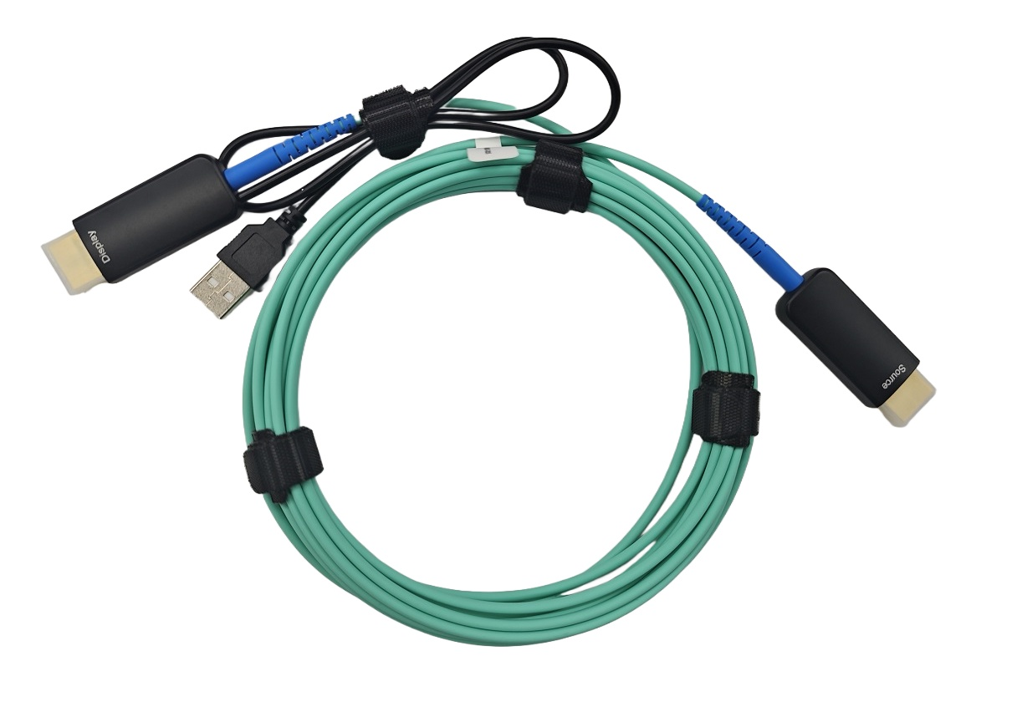
HDMI 2.1 Pure Fiber Cable HDMI 2.0 Pure Fiber Cable
Model: SHPC-8700 Model: SHPC-9860

