Savlink USB-C to HDMI™ Fiber Optic Cable (AOC)

8K@60Hz ▏4K@120Hz ▏30M
Model: (SCTH-1200)

Specification

Edition | Release Date | Change Details | Prepare | Examine and verify | Ratify
1.0 | 2026.6.10 | First Edition Release | R&D
ECN Change History Form
Product View
Break the Limits of Clarity.
The Savlink 8K USB-C to HDMI Active Optical Cable (AOC) is a premium hybrid electro-optical solution engineered for uncompressed audiovisual transmission.Instantly mirror or extend your screen to HDMI TVs/monitors without drivers. Ideal for streaming sports, gaming, and video editing. Direct connection avoids WiFi casting instability.Utilizing advanced fiber optic technology, this hybrid cable eradicates signal loss and crosstalk, delivering pure, zero-lag video transmission even at extreme lengths.
Designed for professionals and enthusiasts, it unleashes the full power of your USB-C® device—supporting breathtaking 8K @ 60Hz​ and hyper-smooth 4K @ 120Hz​ gaming or workflows on Windows, alongside crisp 4K @ 60Hz output on macOS. Whether connecting to high-end monitors, projectors, or docks, this cable guarantees universal compatibility and rock-solid reliability. No adapters, no compromises—just a seamless gateway to immersive visuals and expanded productivity.

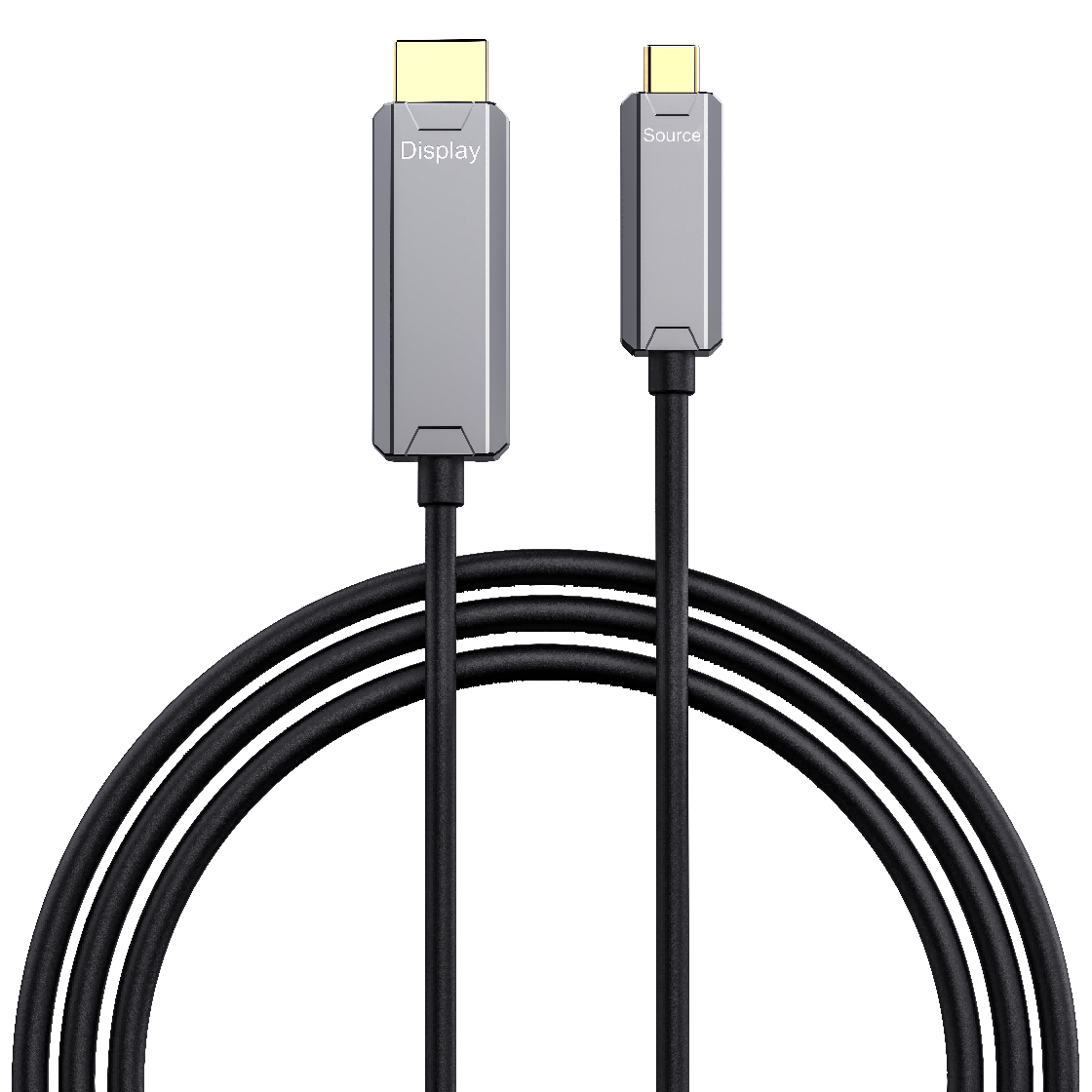

Ⅱ. Product Features
- Hybrid fiber-optic design utilizing high-purity fiber for high-speed signals.
- 48Gbps high-speed transmission.
- Supports 8K@60Hz and 4K@120Hz high refresh rates.
- HDR support with DSC display stream compression technology.
- Compatible with Dynamic HDR, HDCP 2.3, and Dolby Atmos 7.1
- Technology: Ultra-low loss, zero EMI/RFI interference, and zero electromagnetic radiation.
- Driver-free, bus-powered, Hot-plugged, and features auto-detect functionality.
- Industrial-grade components ensure stable performance and high-temperature resistance for 24/7 operation.
- Fully tested with monitors, Notebook ,PC projectors, and docking stations.
- Unidirectional design optimized for maximum stability and immersive visuals.
Ⅲ. Performance Parameters
Parameter | Specification
Interface type | 1x HDMI A Male + 1 x USB C Male Golden Plated
Max Bandwidth​ | 48 Gbps
Max Resolution​ | 7680 × 4320 @ 60Hz (8K UHD) 1080p/1440p @ 240Hz, 4K @ 120Hz, 5K @ 60Hz
Color Format​ | RGB, YCbCr 4:4:4 / 4:2:2 / 4:2:0
Color Depth​ | 8-bit, 10-bit, 12-bit
HDR Support​ | Dynamic HDR, HDR10, HDR10+
HDCP​ | HDCP 2.3
Audio Support​ | DSC 1.2a eARC ,Dolby,Atoms 7.1
Operating Voltage​ | 5V DC
Operating Current​ | ≤ 800 mA
Power Consumption​ | ≤ 4 W
ESD Protection​ | IEC61000-4-2 (Level 4)
Transmission Media​ | OM3 / 50/125 μm Multi-mode Fiber
Cable Construction​ | 4 Optical Fibers + 7 Copper Wires (Hybrid)
Light Source​ | VCSEL (850 nm)
Max Distance​ | 30 m (98.4 ft)
Bit Error Rate (BER)​ | ≤ 10⁻¹²
Cable OD​ | 4.5 ± 0.2 mm TPU
Jacket Material​ | TPU (Black)
Min. Bending Radius​ | 45MM
Mating Cycles​ | ≥ 10,000 times
Directionality​ | Unidirectional​ (USB-C Source → HDMI Display)
Operating Temp.​ | 0°C to +70°C
Storage Temp.​ | -20°C to +85°C
Operating Humidity​ | 5% to 95% RH (Non-condensing)
Storage Humidity​ | 5% to 95% RH (Non-condensing)
Safety and Emission | CE / FCC / RoHS / REACH
Cable length | 5m/7.5m/15m/20m/30m Custom length available.
Shell | Zinc Shell or Custom Design
Package | 1PCS/ Anti-Static Foil Bag + Yellow Box

Ⅳ. Interface Definition
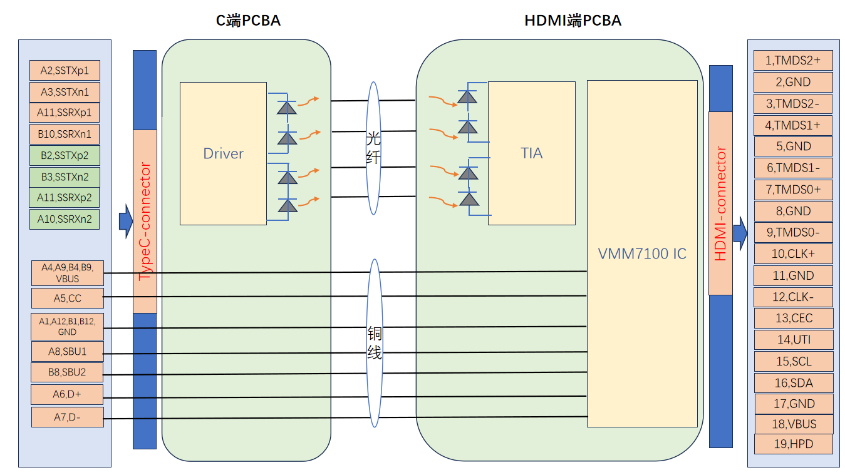
4.1 Savlink USB-C to HDMI™ Fiber Optic Cable (AOC) Typical Interface Circuit
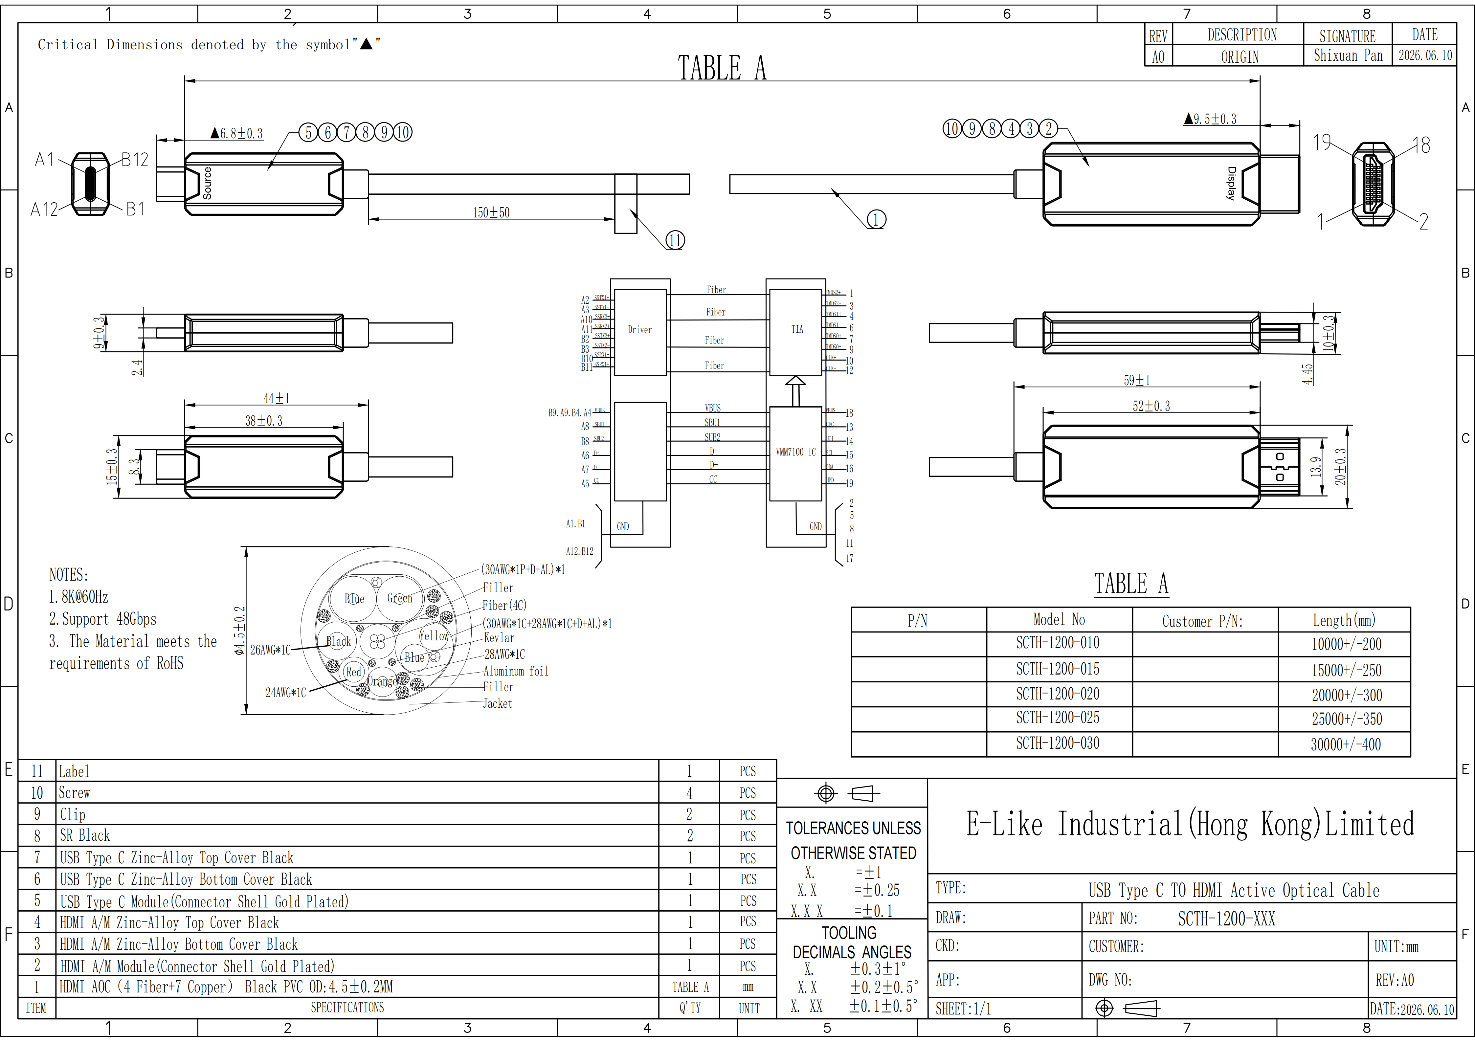

V. Working Principle
- This USB-C to HDMI Active Optical Cable (AOC) adopts a hybrid electro-optical architecture. Inside the USB-C connector, a built-in optical engine converts electrical signals from the host device into optical signals using VCSEL technology.
- These signals are transmitted through four OM3 multi-mode fibers, while seven copper wires carry power and control data.
- At the HDMI connector, a receiving optical engine converts the light back into standard HDMI electrical signals. This design enables lossless 48Gbps transmission up to 30 meters, immune to EMI and free from signal degradation
.Ⅵ. Applications
- Source Devices (USB-C): Laptops, Desktop PCs, Mini PCs, Docking Stations, Handheld Gaming Consoles, Industrial Control Equipment.
- Display Devices (HDMI): LCD Monitors, OLED Monitors, Televisions, Projectors, LED Displays.
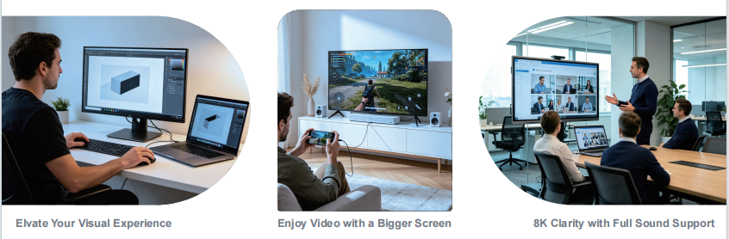

Ⅶ. Q&A
Q1: Does this cable have a specific direction? Will it damage if inserted incorrectly?
A1: Directional connection. The USB-C port connects to a computer or smartphone, while the HDMI port connects to a monitor or TV. Reversing the connection will not damage the device but will result in no image display; always connect according to the labels.
Q2: Can my computer/phone be used?
A2: If your USB-C port supports DP Alt Mode, the Type-C port used solely for charging cannot display video output.
Q3: Do I need to install drivers or an external power supply?
A3: Not required. Plug & Play – power is drawn directly from the USB-C port without an additional adapter.
Q4: Why use this type of "optical fiber cable"? What are its advantages over conventional cables?
A4: For ordinary copper wires longer than 5 meters, 8K signals experience significant attenuation. This cable is an active optical cable (AOC) transmitted via fiber optics, ensuring lossless 8K@60Hz video quality even at 30 meters length, with enhanced electromagnetic interference resistance and a thinner, more flexible design.
Q5: Can a Mac handle 8K resolution fully?
A5: macOS has long been limited to 4K@60Hz (HDMI 2.0 standard). Starting with macOS 26 (Tahoe), M3/M4 Macs can achieve 4K@120Hz when paired with FRL-compatible USB-C to HDMI chips, but still cannot support direct output at 8K@60Hz; M1/M2 processors remain unsupported in testing, and Mac systems cannot handle 8K@60Hz or 4K@240Hz outputs without converters/adapters.
Q6: Does it support HDR and stereo?
A6: Supported. Fully supports Dynamic HDR, HDCP 2.3, and transmits high-fidelity audio such as Dolby Atmos 7.1.
Q7: Is the wire too thin and easy to breaking?
A7: The exterior is made of high-tensile TPU material, while the interior features a 4-ray/7-copper hybrid structure. With a minimum bending radius of approximately 45 cm, it is highly safe for normal bending or pipe installation; do not fold it completely.
Q8: What should I do if there's no screen?
A8: 1) Check if the orientation is reversed;
2)Ensure the display signal source is set to the corresponding HDMI port;
3) Try restarting the device or reduce the resolution for testing;
4) Confirm that the USB-C port supports video output.
Q9: Audio only or Video only?
A9: Select HDMI manually from the system audio output; ensure the HDCP level matches the display (HDCP 2.3)
Q10:Which systems and devices does the cable support?
A10: Windows laptops, macOS devices , certain Android/HarmonyOS smartphones and tablets with video output support, Steam Deck, etc.; monitors/TVs/pro projectors must have a standard HDMI input.
Q11: Does it support dual screens?
A11: The single cable is a unidirectional single-channel cable with one end featuring USB-C and the other HDMI; it does not directly serve as an MST splitter.

