SPECIFICATIONS
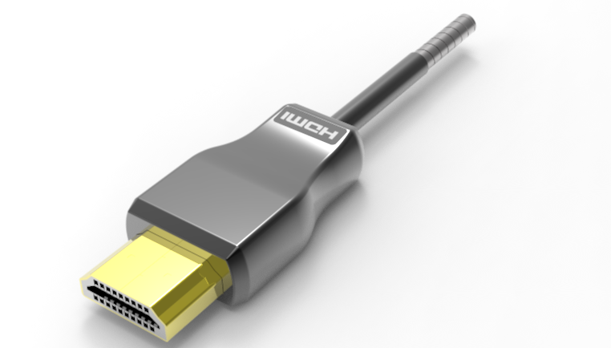

SSAC-9860 Series
Super Slim Armored HDMI 2.1 AOC

DESCRIPTIONS
Savlink developed a super slim armored HDMI Active Hybrid Cable ,with only 3.8mm OD and short HDMI plug ,the most slim Armored HDMI interconnection solution on the market. It supports HDMI Data Rate 12Gbps per channel ,total 48Gbps with strong construction, flexible and ultra-small long-term bending radius (38mm) hybrid cable. With our advanced optical engine embedded. This HDMI Hybrid Cable provides full HDMI signal integrity, support up to 30m maximum length, plug and play. No external power required.

KEY FEATURES
◆ OD3.8mmsuper slim stainless steel construction
◆ Up to 30m Maximum Length.(Custom Length Available)
◆ Support (VRR) Variable refresh rate
◆ Support (HDR) Dynamic HDR formats is supported
◆ Support (QMS) Quick media switching
◆ Support (QFT) Quick frame transport
◆ Support (ALLM) Auto low latency Mode
◆ Support (DSC) Display Stream Compression
◆ Compatible with HDMI 2.1 standard..
◆ Support HDCP2.2/2.3
◆ Self-detecting function for EDID information
◆ No loss of signal – delivering crystal clear digital images instantly.
◆ Support 48Gbps Bandwidth with 4Kp50/60/100/120 and 8Kp50/60.

Applications
◆ Digital Signage
◆ LED signboards in streets and in stadiums
◆ Medical Imaging Equipment
◆ Airplane On-board Video System
◆ Home Theater
◆ Blue-ray, 3D video, Projector, Set-up box, DVR, Game Consoles and Computer
◆ TV Broadcast Station
◆ Conference Room Video Equipment

Absolute Maximum Rating
Parameter | Symbol | Min | Max | Unit
Power Supply Voltage | VCC | 4.5 | 5.5 | V
Operating Temperature | Top | 0 | 50 | °C
Storage Temperature | Ts | -40 | 70 | °C
Relative Humidity | Hs | 10 | 80 | %RH

Recommended Operating Conditions
Parameter | Symbol | Min | Typical | Max | Unit
Power Supply Voltage | VCC | 4.75 | 5.0 | 5.25 | V
Operating Temperature | Top | -40 |  | 80 | °C

Specifications
Item | Description
Units | Transmitter (Source) | Receiver (Sink)
HDCP & DDC | HDCP 2.2/2.3 Fully Support bi-directional EDID and HDCP communication
Video Bandwidth | 12 Gbps x 4Channel (max)+ Clock.
Supported  Resolution & Distance | 480p, 720p, 1080i and 1080p deep color, 4Kp50/60/100/120 and 8Kp50/60 up to 30m
O/E Converter | 4 channel 850 nm VCSEL array | 4 CH GaAs PD array
Connector Type | HDMI type A
Cable Type | Armored Hybrid type with OM3 fiber and copper wire
Cable Length | 5m/10m/15m/20m/30m(with +/-30cm tolerance) Custom length available.
Cable Outer Diameter | 3.8mm
Jacket Outer Material | TPU(Custom)
Cable Weight TBD | Cable Weight TBD
Cable Color TBD | Cable Color TBD
Differential Input | 100 ohm (typ)
Power Consumption | 250mW (max)
Power Supply | Non external power required

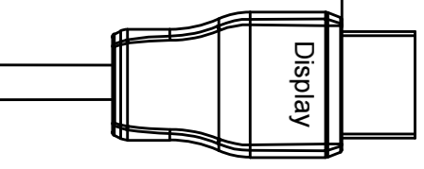
Installation
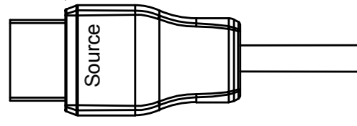
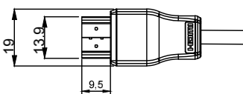
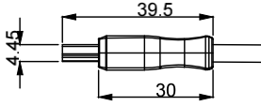

To Source, ex. DVD, PC To Sink, ex. TV
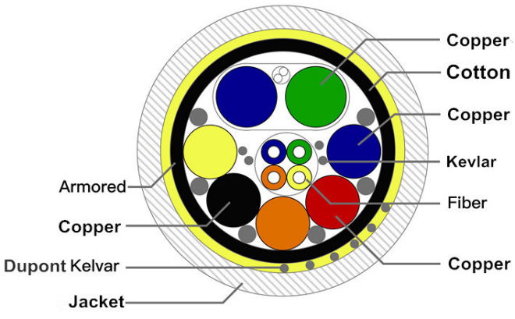
Hybrid Cable Profile

4.5

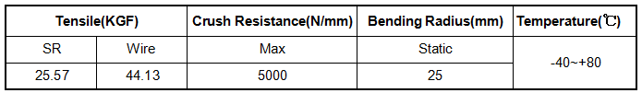

Ordering Information

Part Number | Description
SSAC-9860-005 | Slim Armored HDMI 2.1 AOC4K 2K/60P,Length 5m
SSAC-9860-010 | Slim Armored HDMI 2.1 AOC4K 2K/60P,Length 10m
SSAC-9860-015 | Slim Armored HDMI 2.1 AOC4K 2K/60P,Length 15m
SSAC-9860-020 | Slim Armored HDMI 2.1 AOC4K 2K/60P,Length 20m
SSAC-9860-025 | Slim Armored HDMI 2.1 AOC4K 2K/60P,Length 25m
SSAC-9860-030 | Slim Armored HDMI 2.1 AOC4K 2K/60P,Length 30m

