SPECIFICATIONS
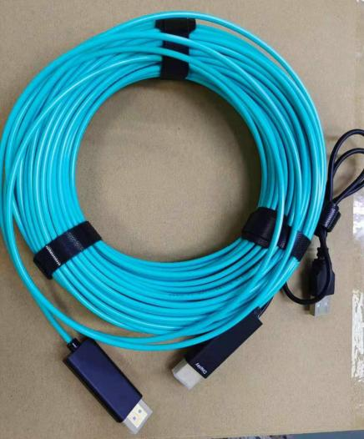

SHPC-8700 Series
HDMI 2.0 Pure Fiber Cable

Descriptions
Smart av link Pure Fiber HDMI Cable is the most competitive long reach HDMI interconnection solution on the market. It supports HDMI Maximum Data Rate 6Gbps with light weight , flexible and ultra- small long-term bending radius (20mm) hybrid cable . With our advanced optical engine embedded. OD3 . 0mm super slim , for cases request no EMI , supporting up to 100m maximum length , plug and play .

E-like Industrial (HK) LTD.
Tel：+86-755-23200789
Web：www.smartavlink.com

Rev:1.0
1 / 4

Key Features
◆ Up to 100m Maximum Length ( Custom Length Available)
◆ Request RX side ( Display Device) self-powered
◆ Plug and Play
◆ Compatible with HDMI 2 . 0 standard
◆ Support HDCP2 .2 , HDR , CEC ,ARC
◆ Self-detecting function for EDID information
◆ No loss of signal – delivering clear digital images instantly
◆ Support computer resolutions to 1080P and 4K2K (60P)

Applications
◆ Digital Signage
◆ LED signboards in streets and in stadiums
◆ Medical Imaging Equipment
◆ Airplane On -board Video System
◆ Home Theater
◆ Blue - ray , 3D video , Projector , Set- up box , DVR , Game Consoles and Computer
◆ TV Broadcast Station
◆ Conference Room Video Equipment
◆ Security systems

Absolute Maximum Rating

Parameter | Symbol | Min | Max | Unit
Power Supply Voltage | VCC | 4 .5 | 5.5 | V
Operating Temperature | Top | 0 | 50 | ° C
Storage Temperature | Ts | -40 | 70 | ° C
Relative Humidity | Hs | 10 | 80 | % RH

Recommended Operating Conditions

Parameter | Symbol | Min | Typical | Max | Unit
Power Supply Voltage | VCC | 4 .75 | 5 .0 | 5 .25 | V
Operating Temperature | Top | 0 |  | 50 | ° C

E-like Industrial (HK) LTD.
Tel：+86-755-23200789
Web：www.smartavlink.com

Rev:1.0 2 / 4

Specifications

Item | Description
Units | Transmitter ( Source) | Receiver ( Sink)
HDCP & DDC | HDCP 2 . 2 Fully Support bi-directional EDID and HDCP communication
Video Bandwidth | 6 Gbps/x3Channel ( max) + Clock .
Supported  Resolution & Distance | PC: WUXGA 1920 x 1200 up to 100 meters ，HDTV : 480p , 720p , 1080i and  1080p deep color , 4K( 60P) , 3DFull HD 1920 x 1080 up to 100 meters
O/ E Converter | 4 channel 850nm VCSEL array | 4 CH GaAs PD array
Connector Type | HDMI type A
Cable Type | OM3 fiber
Cable Length | 15m/ 20m/ 30m/40m/ 50m/ 60m/ 70m/ 80m/ 90m/ 100m (with +/ - 30cm tolerance) Custom length available .
Cable Outer Diameter | 3 . 0mm
Jacket Outer Material | LSZH
Cable Weight TBD | Cable Weight TBD
Cable Color TBD | Cable Color TBD
Differential Input | 100 ohm (typ)
Power Consumption | 250mW ( max)
Power Supply | Request Display Device self-powered
HDMI Type A Pin Assignment
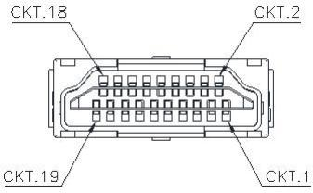

HDMI Type A Connector Pin Assignment

E-like Industrial (HK) LTD.
Tel：+86-755-23200789
Web：www.smartavlink.com

Rev:1.0
3 / 4

PIN | Function | PIN | Function
1 | T . M . D .S . Data 2+ | 11 | TMDS Clock Shield
2 | T . M . D .S . Data 2 Shield | 12 | TMDS Clock-
3 | T . M . D .S . Data 2- | 13 | CEC
4 | T . M . D .S . Data 1+ | 14 | Utility
5 | T . M . D .S . Data 1 Shield | 15 | SCL
6 | T . M . D .S . Data 1- | 16 | SDA
7 | T . M . D .S . Data 0+ | 17 | DDC/ CEC Ground
8 | T . M . D .S . Data 2 Shield | 18 | +5V Power
9 | T . M . D .S . Data 0- | 19 | Hot Plug Detect
10 | TMDS Clock+

Ordering Information

Part Number | Description
SHPC- 8700- 010 | HDMI AOC ，V2 .0 ，4K 2K/ 60P ，Support EDID/ HDCP ，Length 10m
SHPC- 8700- 015 | HDMI AOC ，V2 .0 ，4K 2K/ 60P ，Support EDID/ HDCP ，Length 15m
SHPC- 8700- 020 | HDMI AOC ，V2 .0 ，4K 2K/ 60P ，Support EDID/ HDCP ，Length 20m
SHPC- 8700- 030 | HDMI AOC ，V2 .0 ，4K 2K/ 60P ，Support EDID/ HDCP ，Length 30m
SHPC- 8700- 040 | HDMI AOC ，V2 .0 ，4K 2K/ 60P ，Support EDID/ HDCP ，Length 40m
SHPC- 8700- 050 | HDMI AOC ，V2 .0 ，4K 2K/ 60P ，Support EDID/ HDCP ，Length 50m
SHPC- 8700- 060 | HDMI AOC ，V2 .0 ，4K 2K/ 60P ，Support EDID/ HDCP ，Length 60m
SHPC- 8700- 070 | HDMI AOC ，V2 .0 ，4K 2K/ 60P ，Support EDID/ HDCP ，Length 70m
SHPC- 8700- 080 | HDMI AOC ，V2 .0 ，4K 2K/ 60P ，Support EDID/ HDCP ，Length 80m
SHPC- 8700- 100 | HDMI AOC ，V2 . 0 ，4K 2K/ 60P ，Support EDID/ HDCP ，Length 100m

E-like Industrial (HK) LTD.
Tel：+86-755-23200789
Web：www.smartavlink.com

Rev:1.0 4 / 4

