SPECIFICATIONS
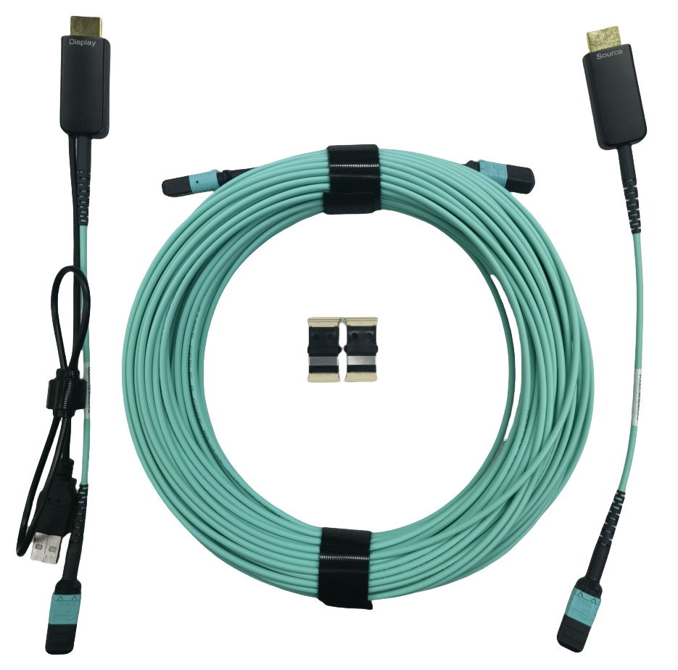

SHMP-8700 Series
MPO Pure Fiber Cable with HDMI 4K AOC

Description
Smartavlink detachable MPO pure fiber HDMI cable is with our advanced optical engine embedded technology. It is using optical fiber between the standard MPO connectors. No EMI and RFI. It supports HDMI 18Gbps bandwidth with light weight, flexible to long distance, specialized for cases which need to pass through the tube. Minimum Bending radius is 30mm. Detachable design is more conducive to later maintenance and product upgrading.

Key Features
◆ MPO port
◆ Up to 100m Maximum Length.(Custom Length Available)
◆ Plug and Play
◆ HDMI2.0 standard
◆ Support HDCP2.3
◆ Support 18G Bandwidth with4K/50P/60P
◆ Self-detecting function for EDID information
◆ HDR formats is supported

Applications
◆ Digital Signage
◆ LED signboards in streets and in stadiums
◆ Medical Imaging Equipment
◆ Airplane On-board Video System
◆ Home Theater
◆ Blue-ray, 3D video, Projector, Set-up box, DVR, Game Consoles and Computer
◆ TV Broadcast Station
◆ Conference Room Video Equipment
◆ Security systems

Absolute Maximum Rating
Parameter | Symbol | Min | Max | Unit
Power Supply Voltage | VCC | 4.5 | 5.5 | V
Operating Temperature | Top | 0 | 50 | °C
Storage Temperature | Ts | -40 | 70 | °C
Relative Humidity | Hs | 10 | 80 | %RH

Recommended Operating Conditions
Parameter | Symbol | Min | Typical | Max | Unit
Power Supply Voltage | VCC | 4.75 | 5.0 | 5.25 | V
Operating Temperature | Top | 0 |  | 50 | °C

Specifications
Item | Description
Units | Transmitter (Source) | Receiver (Sink)
HDCP & DDC | HDCP 2.2 Fully Support bi-directional EDID and HDCP communication
Video Bandwidth | 6 Gbps x 3Channel
Supported  Resolution & Distance | 480p, 720p, 1080i and 1080p deep color, 4Kp50/60 up to 100m
O/E Converter | 6 channel 850 nm VCSEL array | 6 CH GaAs PD array
Connector Type | HDMI type A and MPO
Cable Type | OD:3.0mm, Multimode 50/125 OM3-150, 8Fibers Micro Cable
Cable Length | 5m/10m/15m/20m/25m/30m/40m/50m/60m/70m/80m/90m/100m (with +/-30cm tolerance) Custom length available.
Cable Outer Diameter | 3.0mm
Jacket Outer Material | LSZH(Custom)
Cable Color | Aqua、Black
MPO Insertion loss | ≤0.35dB
MPO Return loss | ≥30dB
Differential Input | 100 ohm
Power Consumption | 0.3W(Source) / 0.4W(Display)

Assembly Diagram
4.5
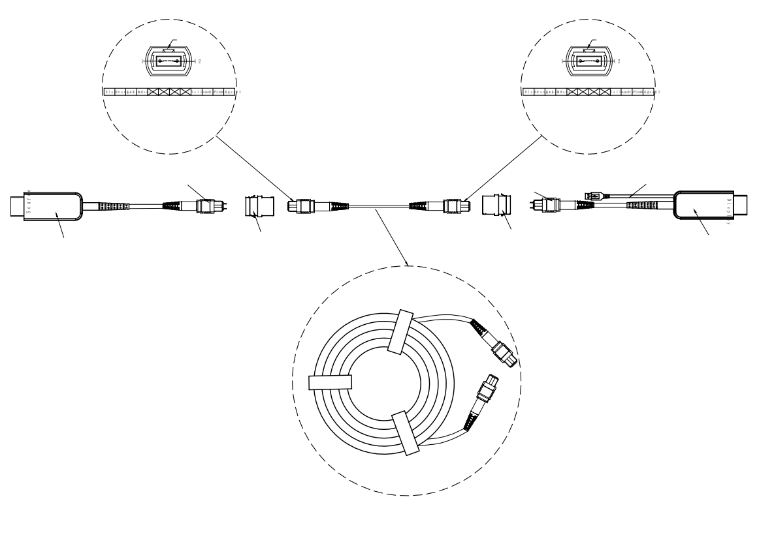
MPO Pure fiber cable (Length Customized)
KeyUp
KeyUp
MPO male connector
MPO male connector
HDMI2.0 AM connector (Source)
HDMI2.0 AM connector (Display)
Adapter
Adapter
USB Power supply cable

Structure Chart
