SPECIFICATIONS

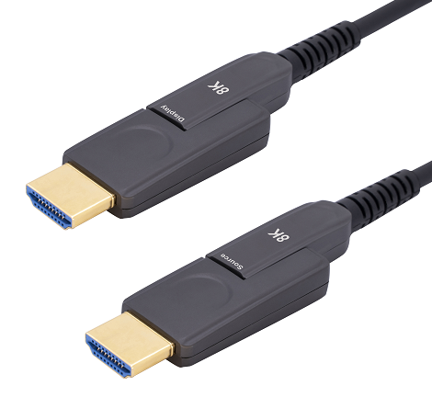

SHDC-9900 Series
HDMI 2.1 Detachable AOC

DESCRIPTIONS
Our new HDMI active Fiber Optic UHD Pluggable HDMI Cable which is suited for critical and versatile installations. It supports HDMI Maximum Data Rate 12Gbps per channel and total 48Gbps bandwidth with light weight, flexible and ultra-small long-term bending radius (45mm) hybrid cable. With our advanced optical engine embedded. This HDMI Hybrid Cable provides full HDMI signal integrity, support up to 100m maximum length, plug and play. No external power required.

KEY FEATURES
◆ Up to 100m Maximum Length.(Custom Length Available)
◆ Plug and Play
◆ Compatible with HDMI 2.1 standard , Backward compatible with HDMI2.0/HDMI1.4
◆ Support HDCP2.2/2.3
◆ Support (HDR) Dynamic HDR formats is supported.
◆ Support (VRR) Variable refresh rate
◆ Support (QMS) Quick media switching
◆ Support (QFT) Quick frame transport
◆ Support (ALLM) Auto low latency Mode
◆ Support (DSC) Display Stream Compression
◆ Support 48Gbps Bandwidth with 4Kp50/60/100/120 and 8Kp50/60
◆ Self-detecting function for EDID information
◆ No loss of signal – delivering crystal clear digital images instantly.
◆ Hybrid optical cable with fiber and copper wire
◆ Includes a DC cable to optionally connect an external 5V power supply(if required, this is typically connected on the display side .)
Remark: Cable is hybrid glass fiber and copper , pull strength should be better within 15KG！！！
Applications
SHDC-9900 is ideal for long distance transmission in professional AV systems, indoor and outdoor digital signage and kiosks, home theater systems, surgical theaters ,facility automation systems and whenever high resolution video and audio are required .On the display side, the micro HDMI connector enables smooth pulling of the cable. The SOURCE end connects to the source (for example, a DVD, Blu-ray or game console box) and the DISPLAY end to the acceptor (for example, a projector, an LCD display or a tablet device .

Absolute Maximum Rating
Parameter | Symbol | Min | Max | Unit
Power Supply Voltage | VCC | 4.5 | 5.5 | V
Operating Temperature | Top | 0 | 50 | °C
Storage Temperature | Ts | -40 | 70 | °C
Relative Humidity | Hs | 10 | 80 | %RH
Recommended Operating Conditions
Parameter | Symbol | Min | Typical | Max | Unit
Power Supply Voltage | VCC | 4.75 | 5.0 | 5.25 | V
Operating Temperature | Top | 0 |  | 50 | °C
Specifications
Item | Description
Units | Transmitter (Source) | Receiver (Sink)
HDCP & DDC | HDCP 2.3 Fully Support bi-directional EDID and HDCP communication
Video Bandwidth | 12 Gbps/x4Channel
Supported  Resolution & Distance | 480p, 720p, 1080i and 1080p deep color, 4Kp50/60/100/120 and 8Kp50/60 up to 100m
O/E Converter | 4 channel 850 nm VCSEL array | 4 CH GaAs PD array
Connector Type | HDMI type A
Cable Type | Hybrid type with OM3 fiber and copper wire
Cable Length | 15m/20m/30m (with +/-20cm tolerance) /100m Custom length available.
Cable Outer Diameter | 4.5mm
Jacket Outer Material | PVC/TPU(Custom)
Cable Weight TBD | Cable Weight TBD
Cable Color TBD | Cable Color TBD
Differential Input | 100 ohm (typ)
Power Consumption | 250mW (max)
Power Supply | Non external power required

Hybrid Cable Profile

4.5

Installation

To Source, ex. DVD, PC To Display, ex. TV

- Unpack the cable from the package with care and remove the cable tie
- Place the micro-HDMI (Type D) connector inside the Pulling Tool and close its cover Note that you should pull the cable from the display side (as shown in below ), and you have to make sure that the cable polarity is correct (tagged Display if pulling the display side)
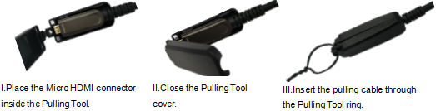
- Attach the pulling cable to the Pulling Tool
- Carefully install the cable (for example, in the wall or conduit or under the floor)
- Connect DISPLAY HDMI adaptor to the micro-HDMI connector DISPLAY end of the cable
- Plug the SOURCE connector head of the cable into the source devices ,Plug the DISPLAY connector head of the cable into the display devices .
- Switch on the power of the source and display devices
- If required, connect an external power source via the DC cable connector on the DISPLAY side

Ordering Information
Part Number | Description
SHDC-9900--010 | HDMI D-D AOC，V2.1，8K 4K/60P，Suport EDID/HDCP，Length 10m
SHDC-9900--030 | HDMI D-D AOC，V2.1，8K 4K/60P，Suport EDID/HDCP，Length 30m
SHDC-9900--050 | HDMI D-D AOC，V2.1，8K 4K/60P，Suport EDID/HDCP，Length50m
SHDC-9900-100 | HDMI D-D AOC，V2.1，8K 4K/60P，Suport EDID/HDCP，Length 100m

Packing Details Sheet:

Item No. | Length(m) | Box Size(mm) | CTN Size(mm) | PCS/CTN | N.W.  (KG/Box) | N.W.  (KG)/CTN | G.W.  (KG)/CTN
SHDC-9900-10 | 10 | 235*225*74 | 47*38.5*25.5 | 10 | 0.7 | 7 | 8
SHDC-9900-15 | 15 | 235*225*74 | 47*38.5*25.5 | 10 | 0.85 | 8.5 | 9.5
SHDC-9900-20 | 20 | 235*225*74 | 47*38.5*25.5 | 10 | 0.795 | 9.5 | 10.5
SHDC-9900-30 | 30 | 235*225*74 | 47*38.5*25.5 | 10 | 1.2 | 12 | 13
SHDC-9900-40 | 40 | 235*225*74 | 47*38.5*25.5 | 10 | 1.45 | 14.5 | 15.5
SHDC-9900-50 | 50 | 285*275*74 | 56.8*40*31 | 10 | 2.05 | 20.5 | 21.5
SHDC-9900-60 | 60 | 285*275*74 | 56.8*40*31 | 10 | 2.25 | 22.5 | 23.5
SHDC-9900-70 | 70 | 335*325*74 | 39*36*34 | 5 | 2.5 | 12.5 | 13
SHDC-9900-80 | 80 | 335*325*74 | 39*36*34 | 5 | 3 | 15 | 16
SHDC-9900-90 | 90 | 335*325*74 | 39*36*34 | 5 | 3.2 | 16 | 17
SHDC-9900-100 | 100 | 335*325*74 | 39*36*34 | 5 | 3.5 | 17.5 | 18.5

