DVI AOC Manual

Description
SDMP-8700 product is a hybrid cable, DVI active optical cable (AOC) with DVI fiber extender over MPO optic cable is a ideal installation solution for used on home , residential , commercial integration , as well as EMC medical-grade projects . It can be replaced at any time without the need to replace the entire cable . There is no loss of signal over long distance and no EMI interference which make it as the best choice for point-to-point and distributed ultra high definition video connections .
E-Like Industrial (HK) Limited
Add: 5F,Avatar Innovation Park , No.8 Xinhe Street ,Shajing Town,Ban’an District ,Shenzhen Tel ：0755-23200789 Web ：www.smartavlink.com

Key Features
1. Long distance transmission, over 100 meters;
2. Single channel DVI interface, support up to 10.2Gbps bandwidth ；
3. Program and store monitor ’s EDID information inside of source connector ;
4. Thinner, lighter and softer than conventional copper cable ;
5. No radiation, and highly resistant with EMI；
6. Supports computer resolutions to 1080P and 4K2K(30P) ;
7. Request no external USB power supply .

Specifications
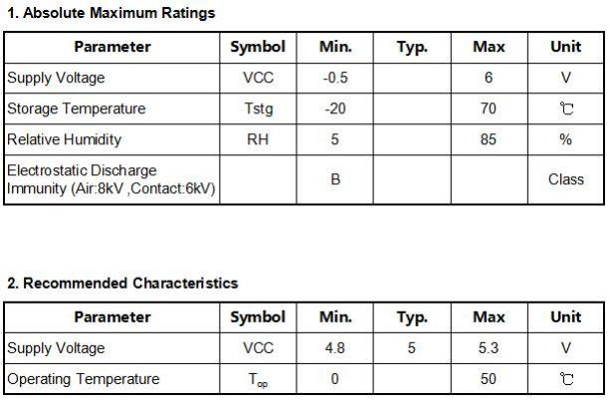

E-Like Industrial (HK) Limited
Add: 5F,Avatar Innovation Park , No.8 Xinhe Street ,Shajing Town,Ban’an District ,Shenzhen Tel ：0755-23200789 Web ：www.smartavlink.com

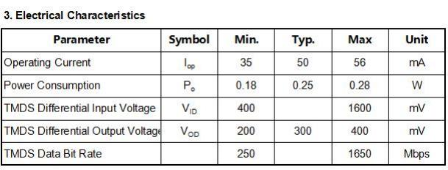

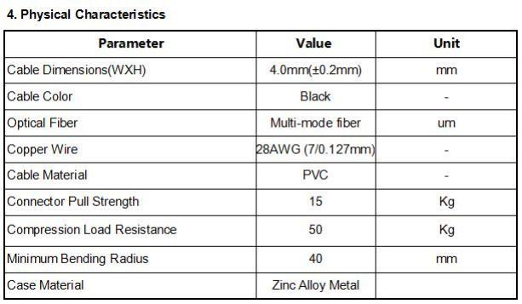

E-Like Industrial (HK) Limited
Add: 5F,Avatar Innovation Park , No.8 Xinhe Street ,Shajing Town,Ban’an District ,Shenzhen Tel ：0755-23200789 Web ：www.smartavlink.com


SDVC-8700 Series
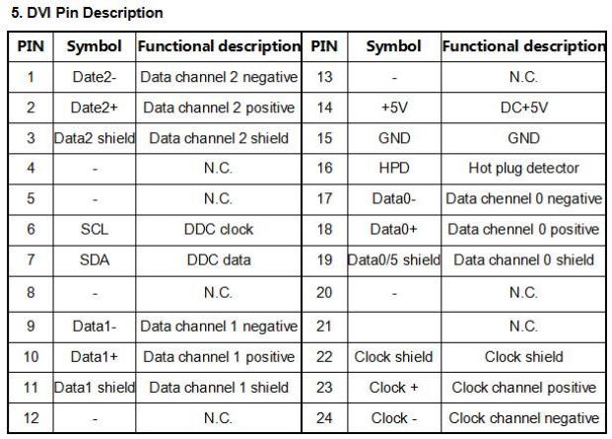

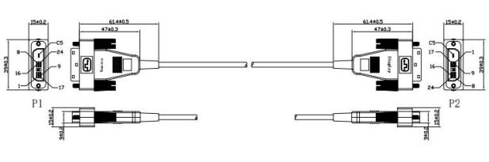

DVI Connector
E-Like Industrial (HK) Limited
Add: 5F,Avatar Innovation Park , No.8 Xinhe Street ,Shajing Town,Ban’an District ,Shenzhen Tel ：0755-23200789 Web ：www.smartavlink.com

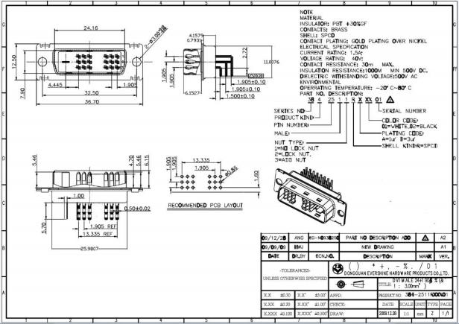
DVI Connector Drawing

Applications
1. Digital Signage , Security systems ,Home Theater ;
2. Conference Room Video Equipment;
3. LED signboards in streets and in stadiums ; TV Broadcast Station;
4. Medical Imaging Equipment ,Airplane On-board Video System;
5. Blue-ray, 3D video, Projector, Set-up box, DVR, Game Consoles and Computer .

E-Like Industrial (HK) Limited
Add: 5F,Avatar Innovation Park , No.8 Xinhe Street ,Shajing Town,Ban’an District ,Shenzhen Tel ：0755-23200789 Web ：www.smartavlink.com

