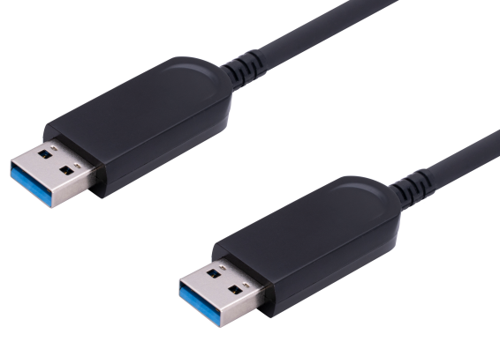

SUAM-3250 USB 3.0 Male to Male Specification
Description
The USB 3.0 Active Optical Cable (AOC) is a USB 3.0 electrical to optical conversion module. This product can translate signals between USB 3.0 electrical and optical signals. AOC is a cabling technology that accepts the same electrical inputs as a traditional copper cable, but using optical fiber“between the connectors”. The USB fiber cable can be up to 15m with USB 3.0 version and also downward compatible with USB 2.0 and USB 1.1 at Device Side.

KEY FEATURES
◆ Extends USB 3.0 & USB 2.0 super speed devices up to 50 m
◆ Supports all USB 3.0 device types at Host: control, interrupt, bulk and isochronous at up to 10 Gbps
◆ Operates with USB 3.0 super speed host controllers
◆ Supports Windows & Mac operating systems
◆ Number of devices can be increased using additional hubs
◆ A substantial increase in USB2.0 device bandwidth with special technology
◆ Ideal for a wire variety of USB devices, from printer, scanners, hard drives,and audio devices,
to touch screens, web cams, and game controllers
Applications
◆ Industrial Control
◆ Digital Signage
◆ Home Network Integration
◆ Medical Device Connectivity
◆ KVM Extension
◆ Remote Desktop USB 3.0 and USB2.0 Connections
◆ Security: web camera, access control
◆ USB 3.0 & USB2.0 Device Sharing: print, scan, storage
SPECIFICATIONS
Product Name | SUAM-3250 Series
Description | USB 3.0 Active Optical Cable downward compatible with USB 2.0
Connector | USB 3.0 Standard-A Male to A male plug
Max. data rate | 10.0Gbps
Range | 164 ft( 50 m) over multimode optical fiber
Optical Transceiver | 850 nm VCSEL (multimode)
Cable diameter | 4.8 mm
Operating Temperature | 0°C to 50°C (32°F to 122°F)
Storage Temperature | -20°C to 70°C (-4°F to 158°F).
Humidity | 5% to 90% (non-condensing)

Absolute Maximum Ratings
Parameter | Symbol | Minimum | Maximum | Units
Supply Voltage | VCC | -0.5 | 5.5 | V
Operating Temperature | Top | 0 | 50 | °C
Storage Temperature | Ts | -20 | 70 | °C
Storage Relative Humidity | Hs | 10 | 85 | %RH

Recommended Operating Conditions
Parameter | Symbol | Minimum | Typical | Maximum | Units
Supply Voltage | VCC | 4.75 | 5 | 5.25 | V
Operating Temperature | Top | 0 |  | 50 | °C
Characteristics
Parameter | Description | Minimum | Typical | Maximum | Units
VCC | Supply Voltage | 4.75 | 5 | 5.25 | V
I_{BUS} | Current at USB Bus Power | 49.5 | 55 | 60.5 | mA
R_{DIFF} | Differential impedance |  | 90 |  | Ω
USB3.0 AOC TX Characteristic
P_{TX} | Optical TX output power | 0 |  |  | dBm
R_{j} | Random jitter |  |  | 3 | ps
D_{j} | Deterministic jitter |  |  | 60 | ps
T_{j} | Total jitter at a 10-12 BER |  |  | 100 | ps
USB3.0 AOC RX Characteristic
S_{RX} | RX sensitivity | -7.5 |  |  | dBm
C_{AC-COUPLING} | AC coupling capacitor on RXOUT | 75 | 100 | 200 | nF
Finished product drawings
