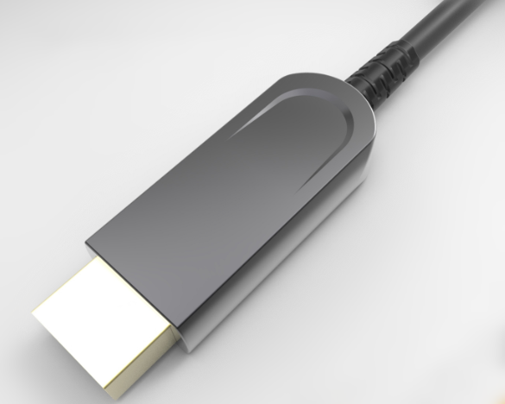

SUAM-3000 SERIES
USB 3.0 Active Optical Cable AM-AM
Description
The USB 3.0 Active Optical Cable (AOC) is a USB 3.0 electrical to optical conversion module. This product can translate signals between USB 3.0 electrical and optical signals. AOC is a cabling technology that accepts the same electrical inputs as a traditional copper cable, but uses optical fiber “between the connectors”. AOC uses electrical to optical conversion on the cable ends to improve speed and distance performance of the cable without sacrificing compatibility with standard electrical interface.USB3.0 AOC can extend the transmission distance of USB3.0 transmission to more than 100 meters .AOC offer a quick solution to supply longer cable for USB3.0application.
KEY FEATURES
◆ Extends USB 3.0 super speed devices up to 100 m
◆ Supports all USB 3.0 device types: control, interrupt, bulk and isochronous at up to 10 Gbps
◆ Operates with USB 3.0 super speed host controllers
◆ Supports all major operating systems including Windows, Mac OS, and Linux
◆ Number of devices can be increased using additional hubs
◆ Power adapter at host is not required
◆ Remote unit require standard power to USB3.0 AOC port
◆ Ideal for a wire variety of USB devices, from printer, scanners, hard drives,and audio devices,
to touch screens, web cams, and game controllers
Applications
◆ Industrial Control
◆ Digital Signage
◆ Home Network Integration
◆ Medical Device Connectivity
◆ KVM Extension
◆ Remote Desktop USB 3.0 Connections
◆ Security: web camera, access control
◆ USB 3.0 Device Sharing: print, scan, storage
Applications Reference
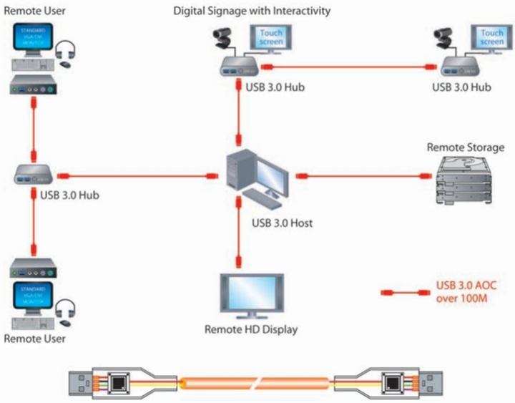
SPECIFICATIONS
Product Name | SUMF-3000 Series
Description | USB 3.0 Hybrid Active Optical Cable A Male to A Female
Connector | USB 3.0 Standard-AMale to A male plug
Max. data rate | 10.0Gbps
Range | 300 ft( 100 m) over mult-imode optical fiber
Optical Transceiver | 850 nm VCSEL (multimode)
Cable diameter | 4.0 mm
Operating Temperature | 0°C to 50°C (32°F to 122°F)
Storage Temperature | -20°C to 70°C (-4°F to 158°F).
Humidity | 5% to 90% (non-condensing)

Absolute Maximum Ratings
Parameter | Symbol | Minimum | Maximum | Units
Supply Voltage | VCC | -0.5 | 5.5 | V
Operating Temperature | Top | 0 | 70 | °C
Storage Temperature | Ts | -40 | 85 | °C
Storage Relative Humidity | Hs | 10 | 85 | %RH

Recommended Operating Conditions
Parameter | Symbol | Minimum | Typical | Maximum | Units
Supply Voltage | VCC | 4.75 | 5 | 5.25 | V
Operating Temperature | Top | 0 |  | 50 | °C

Characteristics

Parameter | Description | Minimum | Typical | Maximum | Units
VCC | Supply Voltage | 4.75 | 5 | 5.25 | V
I_{BUS} | Current at USB Bus Power | 49.5 | 55 | 60.5 | mA
R_{DIFF} | Differential impedance |  | 90 |  | Ω
USB3.0 AOC TX Characteristic
P_{TX} | Optical TX output power | 0 |  |  | dBm
R_{j} | Random jitter |  |  | 3 | ps
D_{j} | Deterministic jitter |  |  | 60 | ps
T_{j} | Total jitter at a 10-12 BER |  |  | 100 | ps
USB3.0 AOC RX Characteristic
S_{RX} | RX sensitivity | -7.5 |  |  | dBm
C_{AC-COUPLING} | AC coupling capacitor on RXOUT | 75 | 100 | 200 | nF

USB 3.0 Standard-A Plug Pin Assignment

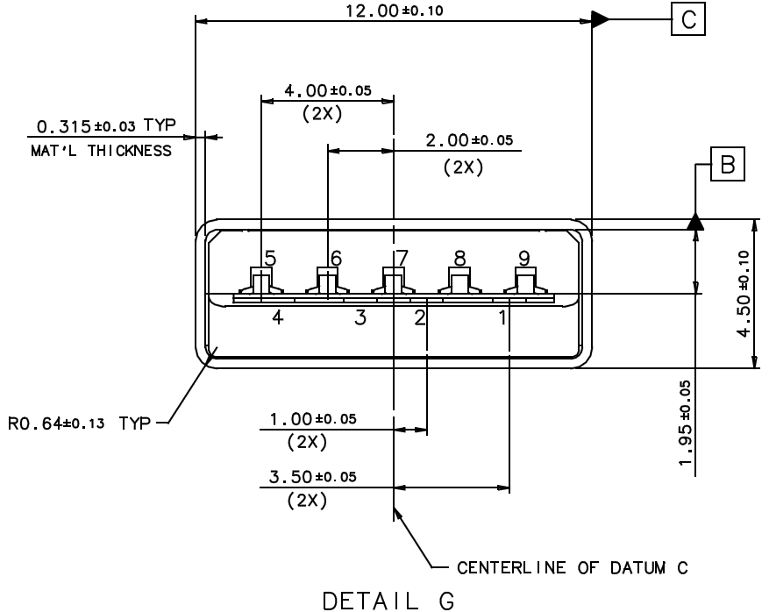

USB 3.0 Standard-A Plug Pin Assignment

Pin number | Signal Name | Description
1 | VBUS | Power
2 | D- | USB 2.0 differential pair
3 | D+ | USB 2.0 differential pair
4 | GND | Ground for power return
5 | SSTX- | SuperSpeed transmitter differential pair
6 | SSTX+ | SuperSpeed transmitter differential pair
7 | GND | Ground for signal return
8 | SSRX- | SuperSpeed receiver differential pair
9 | SSRX+ | SuperSpeed receiver differential pair
Shell | Shield | Shield

Drawing
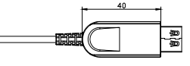
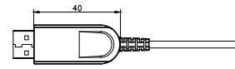

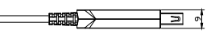
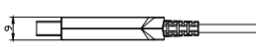

Ordering Information
Part Number | Description
SUAM-3000-010 | USB 3.0 AOC AM-AM, 5Gbps,Length 10m
SUAM-3000-015 | USB 3.0 AOC AM-AM, 5Gbps,Length 15m
SUAM-3000-020 | USB 3.0 AOC AM-AM, 5Gbps,Length 20m
SUAM-3000-030 | USB 3.0 AOC AM-AM, 5Gbps,Length 30m
SUAM-3000-050 | USB 3.0 AOC AM-AM, 5Gbps,Length 50m
SUAM-3000-070 | USB 3.0 AOC AM-AM, 5Gbps,Length 70m
SUAM-3000-080 | USB 3.0 AOC AM-AM, 5Gbps,Length 80m
SUAM-3000-100 | USB 3.0 AOC AM-AM, 5Gbps,Length 100m

