SSHC-9860 HDMI 2.1 A-A

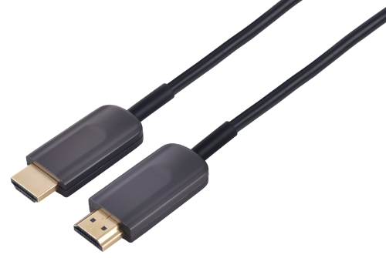

Product Features
- Hybrid optical cable with fiber and copper wire
- Accord with HDMI 2 . 1 standard , backward compatible with HDMI2.0/HDMI1 .4
- Supports computer resolutions to 1080P and 4K2K(60P) and 8Kp50/60
- Support HDCP2 .2/1.4
- Support ( HDR) Dynamic HDR formats
- Support self-detecting function for EDID information
- Support (VRR) Variable refresh rate
- Support (QMS) Quick media switching
- Support (QFT) Quick frame transport
- Support (ALLM) Auto low latency Mode
- Support (DSC) Display Stream Compression
- Support eARC(Enhanced audio return channel)
- No loss of signal – delivering crystal clear digital images instantly
- Plug and Play , no external power required
- Up to 100m Maximum Length.(Custom Length Available)
- OD4.5mmsuper slim stainless steel construction

Applications
- Digital Signage,LED signboards in streets and in stadiums
- Medical Imaging Equipment
- Airplane On-board Video System
- Home Theater,conference Room Video Equipment
- Blue-ray, 3D video, Projector, Set-up box, DVR, Game Consoles and Computer
- TV Broadcast Station
- Conference Room Video Equipment
- Security systems
Operating Condition
Parameter | Unit | Min. | Typical | Max.
Storage Temperature | °C | -40 | 25 | 80
Operating Temperature | °C | -20 |  | 50
Power Supply Voltage | V | 4.5 | 5 | 5.5
Power Consumption | mW |  |  | 250
Bandwidth | Gbps |  |  | 48

Typical Interface Circuit
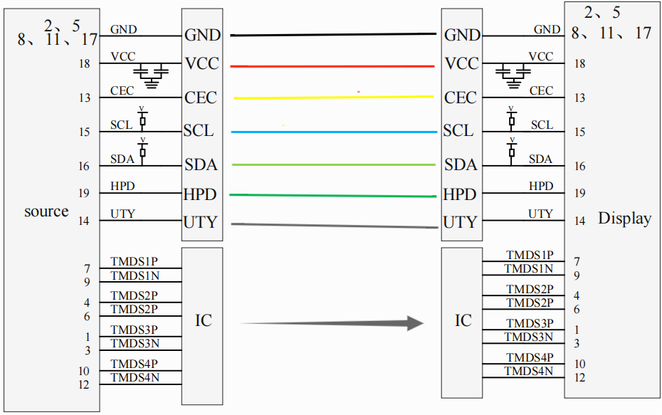

PIN Definition



Finished product drawings

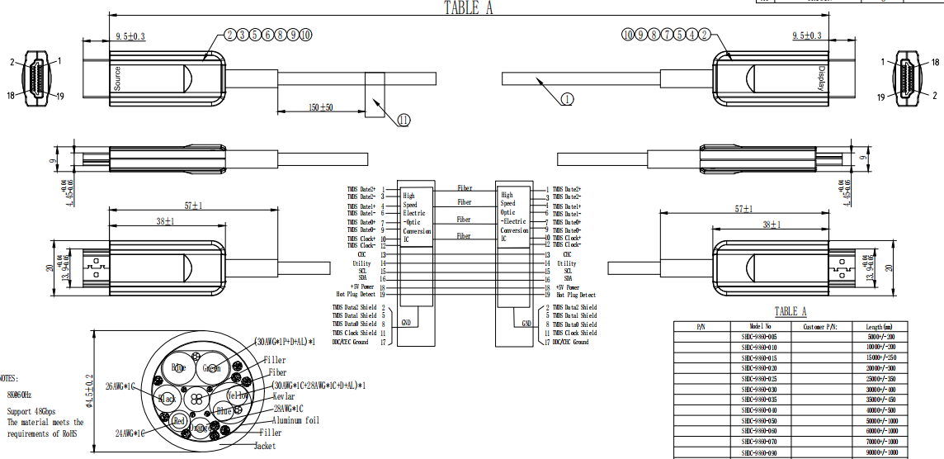

Version number

Version | Date | Description
V001 | 2024-05-28 | New release

