SPECIFICATIONS
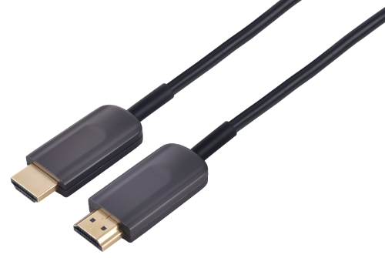

SHDC-9860 Series
HDMI 2.1 AOC

DESCRIPTIONS
Our HDMI Active Hybrid Cable is the most competitive long reach HDMI interconnection solution on the market. It supports HDMI Maximum Data Rate 12Gbps per channel and total 48Gbps bandwidth with light weight, flexible and ultra-small long-term bending radius (45mm) hybrid cable. With our advanced optical engine embedded. This HDMI Hybrid Cable provides full HDMI signal integrity, support up to 30m maximum length, plug and play. No external power required.

KEY FEATURES
◆ Up to 30m Maximum Length.(Custom Length Available)
◆ Plug and Play
◆ Compatible with HDMI 2.1 standard.
◆ Backward compatible with HDMI2.0/HDMI1.4
◆ Support HDCP2.2
◆ Support (HDR) Dynamic HDR formats is supported.
◆ Support (VRR) Variable refresh rate
◆ Support (QMS) Quick media switching
◆ Support (QFT) Quick frame transport
◆ Support (ALLM) Auto low latency Mode
◆ Support (DSC) Display Stream Compression
◆ Support 48Gbps Bandwidth with 4Kp50/60/100/120 and 8Kp50/60
◆ Self-detecting function for EDID information
◆ Support eARC(Enhanced audio return channel)
◆ No loss of signal – delivering crystal clear digital images instantly.
◆ Hybrid optical cable with fiber and copper wire
Applications
◆ Digital Signage
◆ LED signboards in streets and in stadiums
◆ Medical Imaging Equipment
◆ Airplane On-board Video System
◆ Home Theater
◆ Blue-ray, 3D video, Projector, Set-up box, DVR, Game Consoles and Computer
◆ TV Broadcast Station
◆ Conference Room Video Equipment
◆ Security systems

Absolute Maximum Rating
Parameter | Symbol | Min | Max | Unit
Power Supply Voltage | VCC | 4.5 | 5.5 | V
Operating Temperature | Top | 0 | 50 | °C
Storage Temperature | Ts | -40 | 70 | °C
Relative Humidity | Hs | 10 | 80 | %RH
Recommended Operating Conditions
Parameter | Symbol | Min | Typical | Max | Unit
Power Supply Voltage | VCC | 4.75 | 5.0 | 5.25 | V
Operating Temperature | Top | 0 |  | 50 | °C
Specifications
Item | Description
Units | Transmitter (Source) | Receiver (Sink)
HDCP & DDC | HDCP 2.2 Fully Support bi-directional EDID and HDCP communication
Video Bandwidth | 12 Gbps/x4Channel
Supported  Resolution & Distance | 480p, 720p, 1080i and 1080p deep color, 4Kp50/60/100/120 and 8Kp50/60 up to 30m
O/E Converter | 4 channel 850 nm VCSEL array | 4 CH GaAs PD array
Connector Type | HDMI type A
Cable Type | Hybrid type with OM3 fiber and copper wire
Cable Length | 15m/20m/30m (with +/-20cm tolerance) Custom length available.
Cable Outer Diameter | 4.5mm
Jacket Outer Material | PVC/TPU(Custom)
Cable Weight TBD | Cable Weight TBD
Cable Color TBD | Cable Color TBD
Differential Input | 100 ohm (typ)
Power Consumption | 250mW (max)
Power Supply | Non external power required

Hybrid Cable Profile
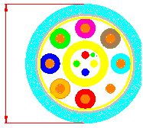
4.5

Ordering Information
Part Number | Description
SHDC-9860--010 | HDMI AOC，V2.1，8K 4K/60P，Suport EDID/HDCP，Length 10m
SHDC-9860--015 | HDMI AOC，V2.1，8K 4K/60P，Suport EDID/HDCP，Length 15m
SHDC-9860--020 | HDMI AOC，V2.1，8K 4K/60P，Suport EDID/HDCP，Length 20m
SHDC-9860--030 | HDMI AOC，V2.1，8K 4K/60P，Suport EDID/HDCP，Length 30m

Packing Details Sheet:
Item No. | Length(m) | Box Size(mm) | CTN Size(cm) | PCS/CTN | N.W.  (KG/Box) | N.W.  (KG)/CTN | G.W.  (KG)/CTN
SHDC-9860-10 | 10 | 235*225*39 | 46.5*42.5*25.5 | 20 | 0.45 | 9 | 10
SHDC-9860-15 | 15 | 235*225*39 | 46.5*42.5*25.5 | 20 | 0.6 | 12 | 13
SHDC-9860-20 | 20 | 235*225*74 | 46.5*42.5*25.5 | 20 | 0.75 | 15 | 16
SHDC-9860-30 | 30 | 235*225*74 | 46.5*42.5*25.5 | 20 | 0.9 | 18 | 19

