DVI AOC Manual

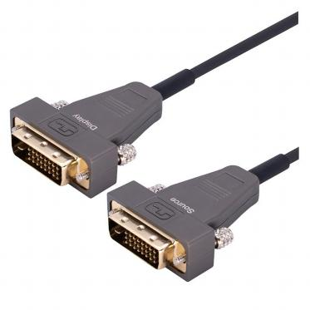

Description
SDVC-8700 product is a hybrid cable, DVI active optical cable (AOC) with high performance, low power consumption and low cost Using optical fiber, to replace copper wire as the high-speed signal transmission medium, DVI AOC can perfectly transmit HD image over 100 meters. Compared with the traditional copper wire, DVI AOC is much longer, softer, more slim with better signal quality and perfect EMI / EMC feature. Compared with other, HDMI optical fiber
transmission solution, DVI AOC is easy to use, no external power supply needed.

E-Like Industrial (HK) Limited
Add: 5F,Avatar Innovation Park , No.8 Xinhe Street ,Shajing Town,Ban’an District ,Shenzhen Tel ：0755-23200789 Web ：www.smartavlink.com

Key Features
1. Long distance transmission, over 100 meters;
2. Single channel DVI interface, support up to 10.2Gbps bandwidth ；
3. Program and store monitor ’s EDID information inside of source connector ;
4. Thinner, lighter and softer than conventional copper cable ;
5. No radiation, and highly resistant with EMI；
6. Supports computer resolutions to 1080P and 4K2K(30P) ;
7. Request no external USB power supply .

Specifications
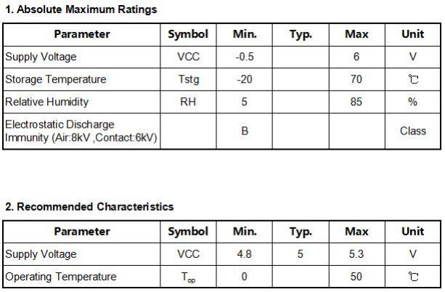

E-Like Industrial (HK) Limited
Add: 5F,Avatar Innovation Park , No.8 Xinhe Street ,Shajing Town,Ban’an District ,Shenzhen Tel ：0755-23200789 Web ：www.smartavlink.com

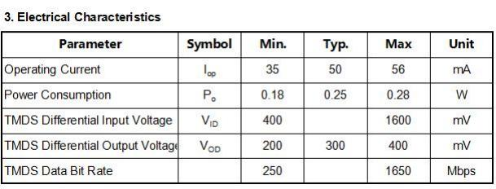

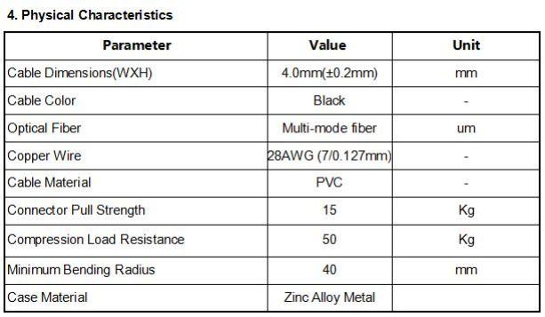

E-Like Industrial (HK) Limited
Add: 5F,Avatar Innovation Park , No.8 Xinhe Street ,Shajing Town,Ban’an District ,Shenzhen Tel ：0755-23200789 Web ：www.smartavlink.com


SDVC-8700 Series
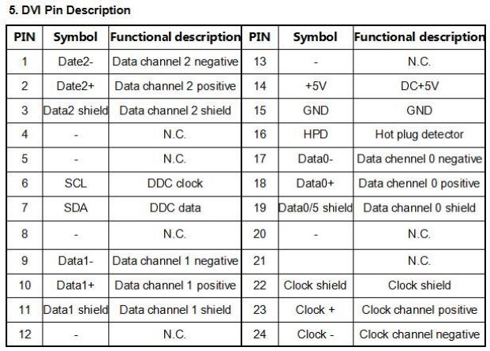

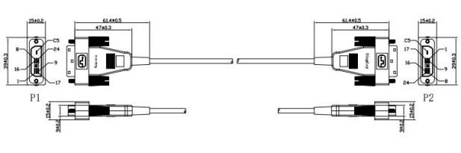

DVI Connector
E-Like Industrial (HK) Limited
Add: 5F,Avatar Innovation Park , No.8 Xinhe Street ,Shajing Town,Ban’an District ,Shenzhen Tel ：0755-23200789 Web ：www.smartavlink.com

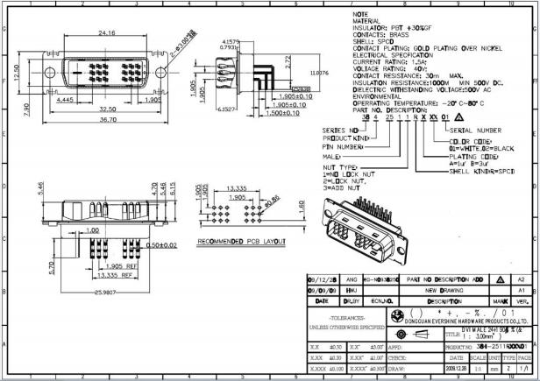
DVI Connector Drawing

Applications
1. Digital Signage , Security systems ,Home Theater ;
2. Conference Room Video Equipment;
3. LED signboards in streets and in stadiums ; TV Broadcast Station;
4. Medical Imaging Equipment ,Airplane On-board Video System;
5. Blue-ray, 3D video, Projector, Set-up box, DVR, Game Consoles and Computer .

E-Like Industrial (HK) Limited
Add: 5F,Avatar Innovation Park , No.8 Xinhe Street ,Shajing Town,Ban’an District ,Shenzhen Tel ：0755-23200789 Web ：www.smartavlink.com

