SPECIFICATIONS
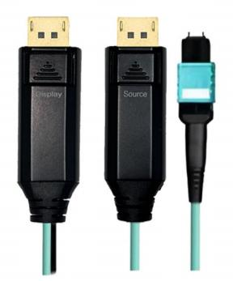

SDMP-1400 Series
DP 1.4 Fiber Extender over MPO Optic Cable

General Description
Smartav link DP1 .4 fiber extender over MPO optic cable is a ideal installation solution for used on home , residential , commercial integration , as well as EMC medical-grade projects . It can be replaced at any time without the need to replace the entire cable . There is no loss of signal over long distance and no EMI interference which make it as the best choice for point-to-point and distributed ultra high definition video connections .

KEY FEATURES
◆ Source / Display DP 1 .4 Fiber Extender
◆ 20cm Long- each side
◆ DP 1 .4 standard
◆ Support 32 .4G Bandwidth with 8K/ 60P , 5K/4K 60P
◆ Support HDCP2 .2
◆ Self-detecting function for EDID information
◆ HDR formats is supported
◆ Up to 100m(330feet) Maximum Length .
◆ Plug and Play

E-like Industrial (HK) LTD.
Tel：+86-755-23224889
Web：www.smartavlink.com

Rev:1.0 1 / 3

MPO Connectors
◆ 12 -Fiber Standard MPO , Polarity Method A
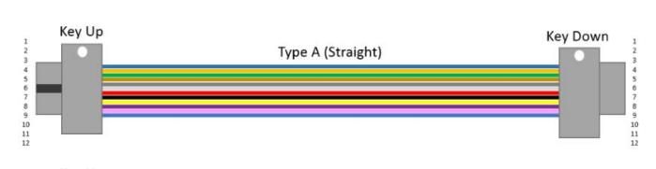
◆ Compatible with MULTIMODE Fiber Optics OM3 OM4 OM5 (cannot work on single mode fiber)

Absolute Maximum Rating

Parameter | Symbol | Min | Max | Unit
Power Supply Voltage | VCC | 4 .5 | 5 .5 | V
Operating Temperature | Top | 0 | 50 | ° C
Storage Temperature | Ts | -40 | 70 | ° C
Relative Humidity | Hs | 10 | 80 | % RH

Recommended Operating Conditions

Parameter | Symbol | Min | Typical | Max | Unit
Power Supply Voltage | VCC | 4 .75 | 5 .0 | 5 .25 | V
Operating Temperature | Top | 0 |  | 50 | ° C

Specifications

Item | Description
Units | Transmitter ( Source) | Receiver ( Sink)
HDCP & DDC | HDCP 2 . 2 Fully Support bi-directional EDID and HDCP communication
Video Bandwidth | 8 . 1 Gbps/x4Channel
Resolution | 480p , 720p , 1080i and 1080p deep color , 4K50/ 60P , 8K60P
O/ E Converter | 6 channel 850 nm VCSEL array | 6 CH GaAs PD array
Connector Type | DP male and MPO
Cable Type | OD:3 . 0mm , Multi mode 50/ 125 OM3 - 150
Cable Outer Diameter | 3 . 0 mm

E-like Industrial (HK) LTD.
Tel：+86-755-23224889
Web：www.smartavlink.com

Rev:1.0
2 / 3

Jacket Outer Material | LSZH
Cable Color | Aqua
MPO Insertion loss | ≤ 0 .35dB
MPO Return loss | ≥ 30dB
Differential Input | 100 ohm
Power Consumption | 0 . 3W( Source) 0 .4W( Display)

Assembly Diagram

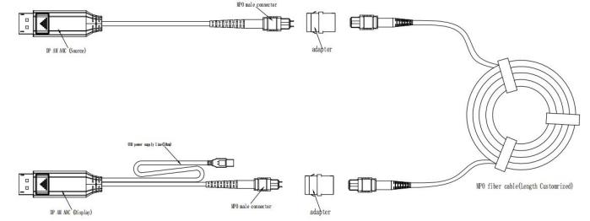

Package Included:
1 . DP1 .4 Fiber Extender (20cm Long- each side )
2 . MPO Adapter x 2pcs ( MPO fiber cable not included in the package , can order separately if need)

E-like Industrial (HK) LTD.
Tel：+86-755-23224889
Web：www.smartavlink.com

Rev:1.0
3 / 3

