SPECIFICATION
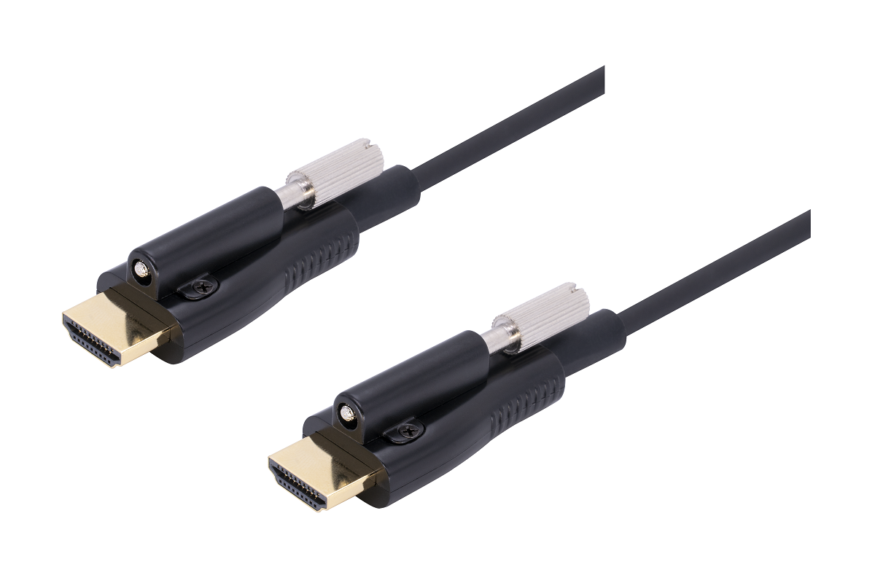
SSHC-8700 Series
Locking HDMI 2.0 AOC

Descriptions
Our Locking HDMI Active Hybrid Cable is the most competitive long reach HDMI interconnection solution on the market. It supports HDMI Maximum Data Rate 6Gbps with light weight, flexible and ultra-small long-term bending radius (45mm) hybrid cable. With our advanced optical engine embedded. This HDMI Hybrid Cable provides full HDMI signal integrity, support up to 100m maximum length, plug and play. No external power required.

Key Features
◆ Up to 100m Maximum Length.(Custom Length Available)
◆ Supports a wide range of resolutions up to 4K@60Hz (color space 4:4:4) 3D and Deep color
◆ Plug and Play
◆ Supports Multi-channel audio, Dolby True HD, DTS-HD Master Audio
◆ Compatible with HDMI 2.0 standard:EDID,CEC,HDCP (2.2), HDR (High Dynamic Range)，HEC,ARC etc.
◆ No loss of signal – delivering crystal clear digital images instantly.
◆ Reduced EMI and RFI
◆ Has high pulling strength and compression load
◆ Has Source&Display clearly printed on the connector for easy identification
◆ Support 18G super speed
◆ Hybrid optical cable with fiber and copper wire

Applications
◆ Digital Signage
◆ LED signboards in streets and in stadiums
◆ Medical Imaging Equipment
◆ Airplane On-board Video System
◆ Home Theater
◆ Blue-ray, 3D video, Projector, Set-up box, DVR, Game Consoles and Computer
◆ TV Broadcast Station
◆ Conference Room Video Equipment
◆ Security systems

Absolute Maximum Rating
Parameter | Symbol | Min | Max | Unit
Power Supply Voltage | VCC | 4.5 | 5.5 | V
Operating Temperature | Top | 0 | 50 | °C
Storage Temperature | Ts | -40 | 70 | °C
Relative Humidity | Hs | 10 | 80 | %RH

Recommended Operating Conditions
Parameter | Symbol | Min | Typical | Max | Unit
Power Supply Voltage | VCC | 4.75 | 5.0 | 5.25 | V
Operating Temperature | Top | 0 |  | 50 | °C
Specifications
Item | Description
Units | Transmitter (Source) | Receiver (Sink)
HDCP & DDC | HDCP 2.0 Fully Support bi-directional EDID and HDCP communication
Video Bandwidth | 6 Gbps/x3Channel (max)+ Clock.
Supported  Resolution & Distance | PC: WUXGA 1920 x 1200 up to 100 meters，HDTV : 480p, 720p, 1080i and 1080p deep color, 4K(60P), 3DFull HD 1920 x 1080 up to 100 meters
O/E Converter | 4 channel 850 nm VCSEL array | 4 CH GaAs PD array
Connector Type | HDMI type A
Cable Type | Hybrid type with OM3 fiber and copper wire
Cable Length | 15m/20m/30m/40m/50m/60m/70m/80m/90m/100m (with +/-30cm tolerance) Custom length available.
Screw | 1pc screw locking on the top of connector
Cable Outer Diameter | 4.5mm
Jacket Outer Material | PVC/TPU(Custom)
Cable Filler | Kevlar
Cable Weight | See packing details sheet
Cable Color | Black or custom
Differential Input | 100 ohm (typ)
Power Consumption | 250mW (max)
Power Supply | Non external power required
HDMI Type A Pin Assignment
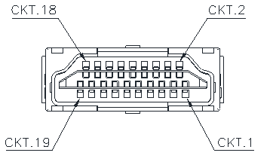

HDMI Type A Connector Pin Assignment
PIN | Function | PIN | Function
1 | T.M.D.S. Data 2+ | 11 | TMDS Clock Shield
2 | T.M.D.S. Data 2 Shield | 12 | TMDS Clock-
3 | T.M.D.S. Data 2- | 13 | CEC
4 | T.M.D.S. Data 1+ | 14 | Utility
5 | T.M.D.S. Data 1 Shield | 15 | SCL
6 | T.M.D.S. Data 1- | 16 | SDA
7 | T.M.D.S. Data 0+ | 17 | DDC/CEC Ground
8 | T.M.D.S. Data 2 Shield | 18 | +5V Power
9 | T.M.D.S. Data 0- | 19 | Hot Plug Detect
10 | TMDS Clock+

Installation

To Source, ex. DVD, PC To Sink, ex. TV
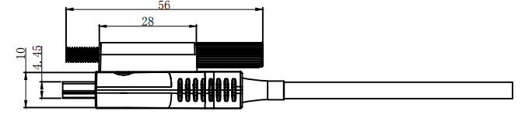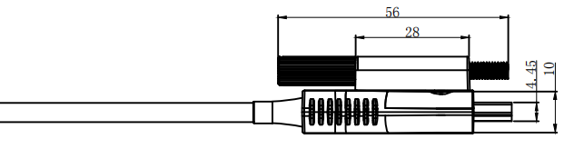


Hybrid Cable Profile
4.5

Ordering Information
Part Number | Description
SSHC-8700-010 | Locking HDMI AOC，V2.0，4K 2K/60P，Support EDID/HDCP，10m
SSHC-8700-015 | Locking HDMI AOC，V2.0，4K 2K/60P，Support EDID/HDCP，15m
SSHC-8700-020 | Locking HDMI AOC，V2.0，4K 2K/60P，Support EDID/HDCP，20m
SSHC-8700-030 | Locking HDMI AOC，V2.0，4K 2K/60P，Support EDID/HDCP，30m
SSHC-8700-040 | Locking HDMI AOC，V2.0，4K 2K/60P，Support EDID/HDCP，40m
SSHC-8700-050 | Locking HDMI AOC，V2.0，4K 2K/60P，Support EDID/HDCP，50m
SSHC-8700-060 | Locking HDMI AOC，V2.0，4K 2K/60P，Support EDID/HDCP，60m
SSHC-8700-070 | Locking HDMI AOC，V2.0，4K 2K/60P，Support EDID/HDCP，70m
SSHC-8700-080 | Locking HDMI AOC，V2.0，4K 2K/60P，Support EDID/HDCP，80m
SSHC-8700-090 | Locking HDMI AOC，V2.0，4K 2K/60P，Support EDID/HDCP，90m
SSHC-8700-100 | Locking HDMI AOC，V2.0，4K 2K/60P，Support EDID/HDCP，100m

