SPECIFICATIONS
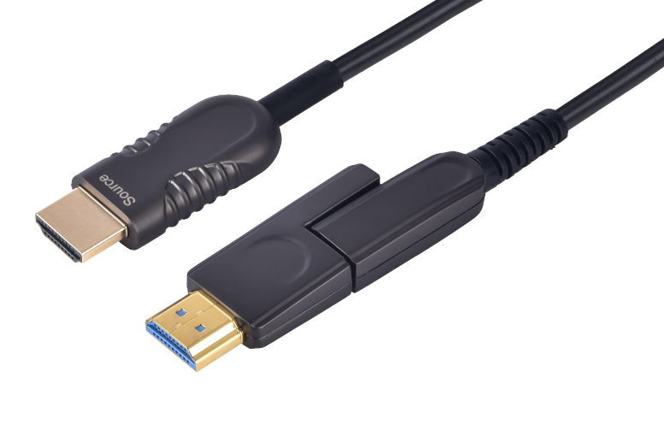

SHDC-8810 Series
HDMI 2.0 detachable A-D AOC
Date:2018-06-19

DESCRIPTIONS
Our new HDMI active Fiber Optic UHD Pluggable HDMI Cable which is suited for critical and versatile installations.It supports HDMI Maximum Data Rate 18Gbps with light weight, flexible and ultra-small long-term bending radius (20mm) hybrid cable. With our advanced optical engine embedded. This HDMI Hybrid Cable provides full HDMI signal integrity, support up to 100m maximum length, plug and play. No external power required.

KEY FEATURES
◆ Supports a wide range of resolutions up to 4K@60Hz (color space 4:4:4) 3D and Deep color
◆ Supports Multi-channel audio, Dolby True HD, DTS-HD Master Audio
◆ Is HDMI compliant: EDID, CEC, HDCP (2.2), HDR (High Dynamic Range)
◆ Reduced EMI and RFI
◆ Has high pulling strength and compression load
◆ Has Source / Display clearly printed on the connector as well as tagged on the cable for easy identification.
◆ Support 18G super speed
◆ Includes a DC cable to optionally connect an external 5V power supply(if required, this is typically connected on the display side .)

Applications
SHDC-8810 is ideal for long distance transmission in professional AV systems, indoor and outdoor digital signage and kiosks, home theater systems, surgical theaters ,facility automation systems and whenever high resolution video and audio are required .On the display side, the micro HDMI connector enables smooth pulling of the cable. The SOURCE end connects to the source (for example, a DVD, Blu-ray or game console box) and the DISPLAY end to the acceptor (for example, a projector, an LCD display or a tablet device .

Absolute Maximum Rating
Parameter | Symbol | Min | Max | Unit
Power Supply Voltage | VCC | 4.5 | 5.5 | V
Operating Temperature | Top | 0 | 50 | °C
Storage Temperature | Ts | -40 | 70 | °C
Relative Humidity | Hs | 10 | 80 | %RH

Recommended Operating Conditions
Parameter | Symbol | Min | Typical | Max | Unit
Power Supply Voltage | VCC | 4.75 | 5.0 | 5.25 | V
Operating Temperature | Top | 0 |  | 50 | °C
Specifications
Item | Description
Units | Transmitter (Source) | Receiver (Display)
HDCP & DDC | HDCP2.2 Fully Support bi-directional EDID and HDCP communication
Video Bandwidth | 6 Gbps /x3Channel (max)+ Clock.
Supported  Resolution & Distance | HDTV : 480p, 720p, 1080i and 1080p deep color, 4K@30Hz, 4K@60Hz(4:4:4), 3D Full HD 1920 x 1080 , up to 100 meters
O/E Converter | 4 channel 850 nm VCSEL array | 4 CH GaAs PD array
Connector Type | HDMI type A, HDMI type D with HDMI D/Female to HDMI A/Male Adaptor
Connector Demension | Type D: 44.2mm x 12.7mm x 7.1mm W, D, H  Type A : 48.2mm x 20mm x 10mm W, D, H  Pulling Tool: 55.2mm x 17.5mm x 13mm W, D, H
Cable Type | Hybrid type with OM3 fiber and copper wire
Cable Length | 15m/20m/30m/40m/50m/60m/70m/80m/90m/100m (with +/-30cm tolerance) Custom length available.
Cable Outer Diameter | 4.5mm
Jacket Outer Material | PVC/TPU(Custom)
Cable Weight TBD | Cable Weight TBD
Cable Color TBD | Cable Color TBD
Differential Input | 100 ohm (typ)
Power Consumption | 250mW (max)

HDMI Type A Pin Assignment
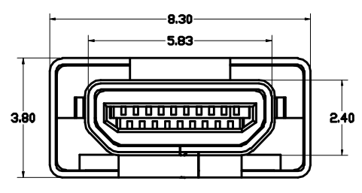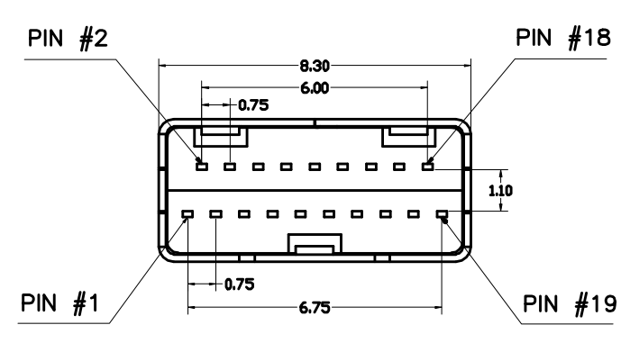

HDMI Type A Connector Pin Assignment
PIN | Function | PIN | Function
1 | T.M.D.S. Data 2+ | 11 | TMDS Clock Shield
2 | T.M.D.S. Data 2 Shield | 12 | TMDS Clock-
3 | T.M.D.S. Data 2- | 13 | CEC
4 | T.M.D.S. Data 1+ | 14 | Utility
5 | T.M.D.S. Data 1 Shield | 15 | SCL
6 | T.M.D.S. Data 1- | 16 | SDA
7 | T.M.D.S. Data 0+ | 17 | DDC/CEC Ground
8 | T.M.D.S. Data 2 Shield | 18 | +5V Power
9 | T.M.D.S. Data 0- | 19 | Hot Plug Detect
10 | TMDS Clock+

Installation
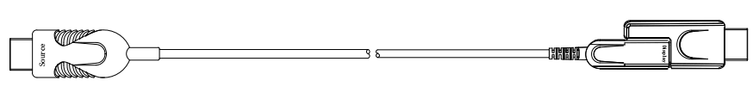
To Source, ex. DVD, PC To Display, ex. TV

- Unpack the cable from the package with care and remove the cable tie
- Place the micro-HDMI (Type D) connector inside the Pulling Tool and close its cover Note that you should pull the cable from the display side (as shown in below ), and you have to make sure that the cable polarity is correct (tagged Display if pulling the display side)
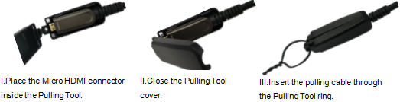
- Attach the pulling cable to the Pulling Tool
- Carefully install the cable (for example, in the wall or conduit or under the floor)
- Connect DISPLAY HDMI adaptor to the micro-HDMI connector DISPLAY end of the cable
- Plug the SOURCE connector head of the cable into the source devices ,Plug the DISPLAY connector head of the cable into the display devices .
- Switch on the power of the source and display devices
- If required, connect an external power source via the DC cable connector on the DISPLAY side

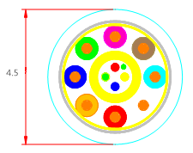
Hybrid Cable Profile

Ordering Information
Part Number | Description
SHDC-8810-010 | HDMI AOC，V2.0，4Kx2K/60P，Suport EDID/HDCP，Length 10m
SHDC-8810-015 | HDMI AOC，V2.0，4K 2K/60P，Suport EDID/HDCP，Length 15m
SHDC-8810-020 | HDMI AOC，V2.0，4K 2K/60P，Suport EDID/HDCP，Length 20m
SHDC-8810-030 | HDMI AOC，V2.0，4K 2K/60P，Suport EDID/HDCP，Length 30m
SHDC-8810-040 | HDMI AOC，V2.0，4K 2K/60P，Suport EDID/HDCP，Length 40m
SHDC-8810-050 | HDMI AOC，V2.0，4K 2K/60P，Suport EDID/HDCP，Length 50m
SHDC-8810-060 | HDMI AOC，V2.0，4K 2K/60P，Suport EDID/HDCP，Length 60m
SHDC-8810-070 | HDMI AOC，V2.0，4K 2K/60P，Suport EDID/HDCP，Length 70m
SHDC-8810-080 | HDMI AOC，V2.0，4K 2K/60P，Suport EDID/HDCP，Length 80m
SHDC-8810-090 | HDMI AOC，V2.0，4K 2K/60P，Suport EDID/HDCP，Length 90m
SHDC-8810-100 | HDMI AOC，V2.0，4K 2K/60P，Suport EDID/HDCP，Length 100m

Packing Details:
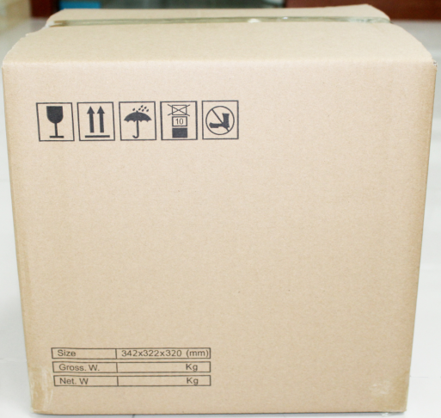
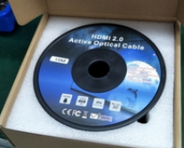

5PCS/CARTON FOR 70M to 100M

10PCS/CARTON FOR 10M to 60M

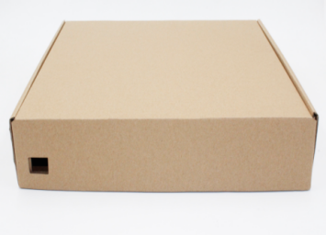

Inner Box Outer Carton

Packing Details Sheet:

Item No. | Length(m) | Box Size(mm) | CTN Size(mm) | PCS/CTN | N.W.  (KG/Box) | N.W.  (KG)/CTN | G.W.  (KG)/CTN
SHDC-8810-10 | 10 | 200*200*65 | 47*38.5*25.5 | 10 | 0.7 | 7 | 8
SHDC-8810-15 | 15 | 200*200*65 | 47*38.5*25.5 | 10 | 0.85 | 8.5 | 9.5
SHDC-8810-20 | 20 | 200*200*65 | 47*38.5*25.5 | 10 | 0.795 | 9.5 | 10.5
SHDC-8810-30 | 30 | 200*200*65 | 47*38.5*25.5 | 10 | 1.2 | 12 | 13
SHDC-8810-40 | 40 | 250*250*65 | 47*38.5*25.5 | 10 | 1.45 | 14.5 | 15.5
SHDC-8810-50 | 50 | 250*250*65 | 56.8*40*31 | 10 | 2.05 | 20.5 | 21.5
SHDC-8810-60 | 60 | 250*250*65 | 56.8*40*31 | 10 | 2.25 | 22.5 | 23.5
SHDC-8810-70 | 70 | 315*305*65 | 39*36*34 | 5 | 2.5 | 12.5 | 13
SHDC-8810-80 | 80 | 315*305*65 | 39*36*34 | 5 | 3 | 15 | 16
SHDC-8810-90 | 90 | 315*305*65 | 39*36*34 | 5 | 3.2 | 16 | 17
SHDC-8810-100 | 100 | 315*305*65 | 39*36*34 | 5 | 3.5 | 17.5 | 18.5

