SPECIFICATIONS
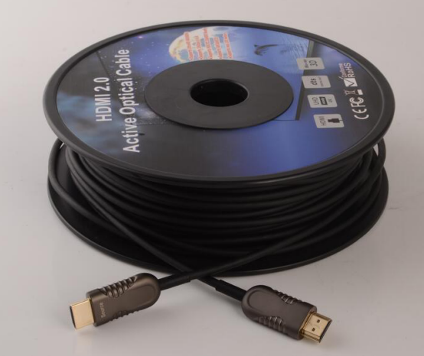

SHDC-8700 Series
HDMI 2.0 AOC

DESCRIPTIONS
Our HDMI Active Hybrid Cable is the most competitive long reach HDMI interconnection solution on the market. It supports HDMI Maximum Data Rate 6Gbps with light weight, flexible and ultra-small long-term bending radius (20mm) hybrid cable. With our advanced optical engine embedded. This HDMI Hybrid Cable provides full HDMI signal integrity, support up to 100m maximum length, plug and play. No external power required.

KEY FEATURES
◆ Up to 100m Maximum Length.(Custom Length Available)
◆ Low Power Consumption: 250mW (max). (Power Required)
◆ Plug and Play
◆ Compatible with HDMI 2.0 standard.
◆ Support HDCP2.2,HDR, CEC,ARC
◆ Self-detecting function for EDID information
◆ No loss of signal – delivering crystal clear digital images instantly.
◆ Supports computer resolutions to 1080P and 4K2K(60P).
◆ Hybrid optical cable with fiber and copper wire
Applications
◆ Digital Signage
◆ LED signboards in streets and in stadiums
◆ Medical Imaging Equipment
◆ Airplane On-board Video System
◆ Home Theater
◆ Blue-ray, 3D video, Projector, Set-up box, DVR, Game Consoles and Computer
◆ TV Broadcast Station
◆ Conference Room Video Equipment
◆ Security systems

Absolute Maximum Rating
Parameter | Symbol | Min | Max | Unit
Power Supply Voltage | VCC | 4.5 | 5.5 | V
Operating Temperature | Top | 0 | 50 | °C
Storage Temperature | Ts | -40 | 70 | °C
Relative Humidity | Hs | 10 | 80 | %RH

Recommended Operating Conditions
Parameter | Symbol | Min | Typical | Max | Unit
Power Supply Voltage | VCC | 4.75 | 5.0 | 5.25 | V
Operating Temperature | Top | 0 |  | 50 | °C
Specifications
Item | Description
Units | Transmitter (Source) | Receiver (Sink)
HDCP & DDC | HDCP 2.2 Fully Support bi-directional EDID and HDCP communication
Video Bandwidth | 6 Gbps/x3Channel (max)+ Clock.
Supported  Resolution & Distance | PC: WUXGA 1920 x 1200 up to 100 meters，HDTV : 480p, 720p, 1080i and 1080p deep color, 4K(60P), 3DFull HD 1920 x 1080 up to 100 meters
O/E Converter | 4 channel 850 nm VCSEL array | 4 CH GaAs PD array
Connector Type | HDMI type A
Cable Type | Hybrid type with OM3 fiber and copper wire
Cable Length | 15m/20m/30m/40m/50m/60m/70m/80m/90m/100m (with +/-30cm tolerance) Custom length available.
Cable Outer Diameter | 4.5mm
Jacket Outer Material | PVC/TPU(Custom)
Cable Weight TBD | Cable Weight TBD
Cable Color TBD | Cable Color TBD
Differential Input | 100 ohm (typ)
Power Consumption | 250mW (max)
Power Supply | Non external power required
HDMI Type A Pin Assignment
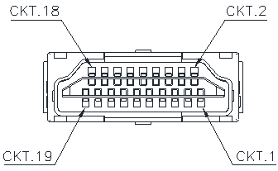

HDMI Type A Connector Pin Assignment
PIN | Function | PIN | Function
1 | T.M.D.S. Data 2+ | 11 | TMDS Clock Shield
2 | T.M.D.S. Data 2 Shield | 12 | TMDS Clock-
3 | T.M.D.S. Data 2- | 13 | CEC
4 | T.M.D.S. Data 1+ | 14 | Utility
5 | T.M.D.S. Data 1 Shield | 15 | SCL
6 | T.M.D.S. Data 1- | 16 | SDA
7 | T.M.D.S. Data 0+ | 17 | DDC/CEC Ground
8 | T.M.D.S. Data 2 Shield | 18 | +5V Power
9 | T.M.D.S. Data 0- | 19 | Hot Plug Detect
10 | TMDS Clock+

Installation

To Source, ex. DVD, PC To Sink, ex. TV
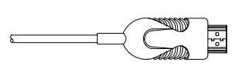
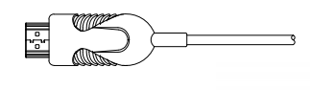

Hybrid Cable Profile
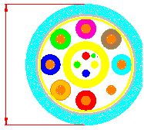
4.5

Ordering Information
Part Number | Description
SHDC-8700-FM-010 | HDMI AOC，V2.0，4K 2K/60P，Suport EDID/HDCP，Length 10m
SHDC-8700-FM-015 | HDMI AOC，V2.0，4K 2K/60P，Suport EDID/HDCP，Length 15m
SHDC-8700-FM-020 | HDMI AOC，V2.0，4K 2K/60P，Suport EDID/HDCP，Length 20m
SHDC-8700-FM-030 | HDMI AOC，V2.0，4K 2K/60P，Suport EDID/HDCP，Length 30m
SHDC-8700-FM-040 | HDMI AOC，V2.0，4K 2K/60P，Suport EDID/HDCP，Length 40m
SHDC-8700-FM-050 | HDMI AOC，V2.0，4K 2K/60P，Suport EDID/HDCP，Length 50m
SHDC-8700-FM-060 | HDMI AOC，V2.0，4K 2K/60P，Suport EDID/HDCP，Length 60m
SHDC-8700-FM-070 | HDMI AOC，V2.0，4K 2K/60P，Suport EDID/HDCP，Length 70m
SHDC-8700-FM-080 | HDMI AOC，V2.0，4K 2K/60P，Suport EDID/HDCP，Length 80m
SHDC-8700-FM-090 | HDMI AOC，V2.0，4K 2K/60P，Suport EDID/HDCP，Length 90m
SHDC-8700-FM-100 | HDMI AOC，V2.0，4K 2K/60P，Suport EDID/HDCP，Length 100m

Packing Details:
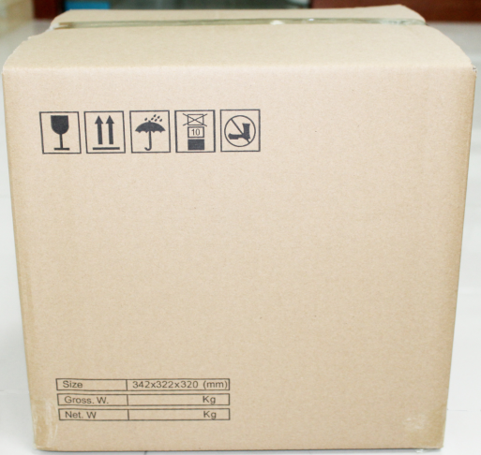
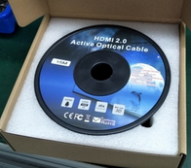

5PCS/CARTON FOR 70M to 100M

10PCS/CARTON FOR 10M to 60M

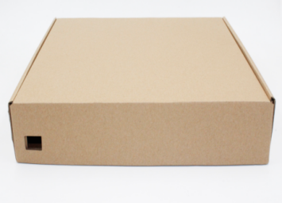

Inner Box Outer Carton
Packing Details Sheet:

Item No. | Length(m) | Box Size(mm) | CTN Size(cm) | PCS/CTN | N.W.  (KG/Box) | N.W.  (KG)/CTN | G.W.  (KG)/CTN
SHDC-8700-10 | 10 | 235*225*74 | 47*38.5*25.5 | 10 | 0.7 | 7 | 8
SHDC-8700-15 | 15 | 235*225*74 | 47*38.5*25.5 | 10 | 0.85 | 8.5 | 9.5
SHDC-8700-20 | 20 | 235*225*74 | 47*38.5*25.5 | 10 | 0.95 | 9.5 | 10.5
SHDC-8700-30 | 30 | 235*225*74 | 47*38.5*25.5 | 10 | 1.2 | 12 | 13
SHDC-8700-40 | 40 | 235*225*74 | 47*38.5*25.5 | 10 | 1.45 | 14.5 | 15.5
SHDC-8700-50 | 50 | 285*275*74 | 56.8*40*31 | 10 | 2.05 | 20.5 | 21.5
SHDC-8700-60 | 60 | 285*275*74 | 56.8*40*31 | 10 | 2.25 | 22.5 | 23.5
SHDC-8700-70 | 70 | 335*325*74 | 39*36*34 | 5 | 2.5 | 12.5 | 13
SHDC-8700-80 | 80 | 335*325*74 | 39*36*34 | 5 | 3 | 15 | 16
SHDC-8700-90 | 90 | 335*325*74 | 39*36*34 | 5 | 3.2 | 16 | 17
SHDC-8700-100 | 100 | 335*325*74 | 39*36*34 | 5 | 3.5 | 17.5 | 18.5

