SPECIFICATIONS

SAHC-8810 Series
Armored HDMI 2.0 A-D AOC

DESCRIPTIONS
Our armored HDMI Active Hybrid Cable is the most competitive long reach HDMI interconnection solution on the market. It supports HDMI Data Rate 6Gbps per channel ,total 18Gbps with light weight, flexible and ultra-small long-term bending radius (45mm) hybrid cable. With our advanced optical engine embedded. This HDMI Hybrid Cable provides full HDMI signal integrity, support up to 100m maximum length, plug and play. No external power required.

KEY FEATURES
◆ Up to 100m Maximum Length.(Custom Length Available)
◆ Low Power Consumption: 250mW (max).
◆ Plug and Play
◆ Compatible with HDMI 2.0 standard.
◆ Support HDCP1.4/2.2
◆ Self-detecting function for EDID information
◆ No loss of signal – delivering crystal clear digital images instantly.
◆ Supports computer resolutions to 1080P and 4K2K(60P).
◆ Hybrid optical cable with fiber and copper wire
◆Crush Resistance: Long term100kg ; Short term 200kg

Applications
◆ Digital Signage
◆ LED signboards in streets and in stadiums
◆ Medical Imaging Equipment
◆ Airplane On-board Video System
◆ Home Theater
◆ Blue-ray, 3D video, Projector, Set-up box, DVR, Game Consoles and Computer
◆ TV Broadcast Station
◆ Conference Room Video Equipment
◆ Security systems

Absolute Maximum Rating
Parameter | Symbol | Min | Max | Unit
Power Supply Voltage | VCC | 4.5 | 5.5 | V
Operating Temperature | Top | 0 | 50 | °C
Storage Temperature | Ts | -40 | 70 | °C
Relative Humidity | Hs | 10 | 80 | %RH

Recommended Operating Conditions
Parameter | Symbol | Min | Typical | Max | Unit
Power Supply Voltage | VCC | 4.75 | 5.0 | 5.25 | V
Operating Temperature | Top | 0 |  | 50 | °C

Specifications
Item | Description
Units | Transmitter (Source) | Receiver (Sink)
HDCP & DDC | HDCP 2.2 Fully Support bi-directional EDID and HDCP communication
Video Bandwidth | 6 Gbps/x3Channel (max)+ Clock.
Supported  Resolution & Distance | PC: WUXGA 1920 x 1200 up to 100 meters，HDTV : 480p, 720p, 1080i and 1080p deep color, 4K(60P), 3DFull HD 1920 x 1080 up to 100 meters
O/E Converter | 4 channel 850 nm VCSEL array | 4 CH GaAs PD array
Connector Type | HDMI type A + HDMI Type D
Cable Type | Armored Hybrid type with OM3 fiber and copper wire
Cable Length | 15m/20m/30m/40m/50m/60m/70m/80m/90m/100m (with +/-30cm tolerance) Custom length available.
Cable Outer Diameter | 5.8mm
Jacket Outer Material | TPU(Custom)
Cable Weight TBD | Cable Weight TBD
Cable Color TBD | Cable Color TBD
Differential Input | 100 ohm (typ)
Power Consumption | 250mW (max)
Power Supply | Non external power required

HDMI Type A Pin Assignment

HDMI Type A Connector Pin Assignment

PIN | Function | PIN | Function
1 | T.M.D.S. Data 2+ | 11 | TMDS Clock Shield
2 | T.M.D.S. Data 2 Shield | 12 | TMDS Clock-
3 | T.M.D.S. Data 2- | 13 | CEC
4 | T.M.D.S. Data 1+ | 14 | Utility
5 | T.M.D.S. Data 1 Shield | 15 | SCL
6 | T.M.D.S. Data 1- | 16 | SDA
7 | T.M.D.S. Data 0+ | 17 | DDC/CEC Ground
8 | T.M.D.S. Data 2 Shield | 18 | +5V Power
9 | T.M.D.S. Data 0- | 19 | Hot Plug Detect
10 | TMDS Clock+

Installation
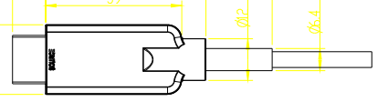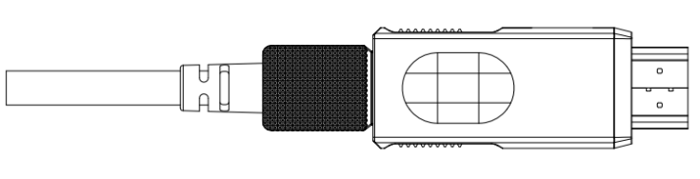

To Source, ex. DVD, PC To Sink, ex. TV

Hybrid Cable Profile
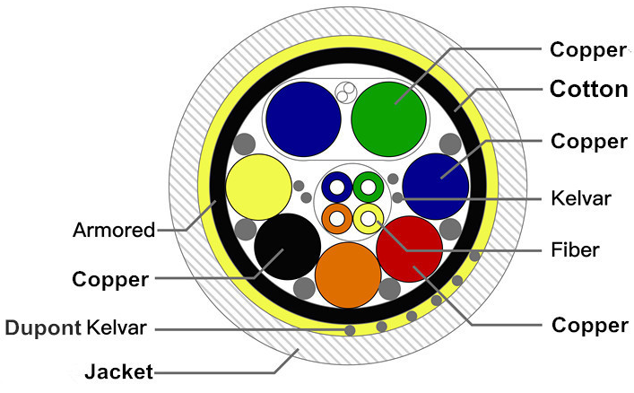

4.5

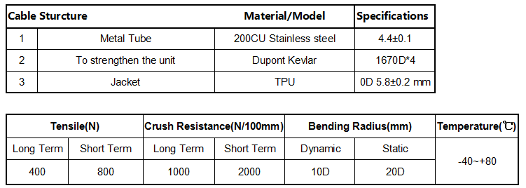

Ordering Information

Part Number | Description
SAHC-8810-010 | Armored HDMI 2.0 AOC4K 2K/60P,Suport EDID/HDCP,Length 10m
SAHC-8810-015 | Armored HDMI 2.0 AOC4K 2K/60P,Suport EDID/HDCP,Length 15m
SAHC-8810-020 | Armored HDMI 2.0 AOC4K 2K/60P,Suport EDID/HDCP,Length 20m
SAHC-8810-030 | Armored HDMI 2.0 AOC4K 2K/60P,Suport EDID/HDCP,Length 30m
SAHC-8810-040 | Armored HDMI 2.0 AOC4K 2K/60P,Suport EDID/HDCP,Length 40m
SAHC-8810-050 | Armored HDMI 2.0 AOC4K 2K/60P,Suport EDID/HDCP,Length 50m
SAHC-8810-060 | Armored HDMI 2.0 AOC4K 2K/60P,Suport EDID/HDCP,Length 60m
SAHC-8810-070 | Armored HDMI 2.0 AOC4K 2K/60P,Suport EDID/HDCP,Length 70m
SAHC-8810-080 | Armored HDMI 2.0 AOC4K 2K/60P,Suport EDID/HDCP,Length 80m
SAHC-8810-090 | Armored HDMI 2.0 AOC4K 2K/60P,Suport EDID/HDCP,Length 90m
SAHC-8810-100 | Armored HDMI 2.0 AOC4K 2K/60P,Suport EDID/HDCP,Length 100m

